1) A 18 year old boy presented in OPD wiht Lt mono articular knee pain. Possible is/are :
Choose 2 of the following options. 
 Gout 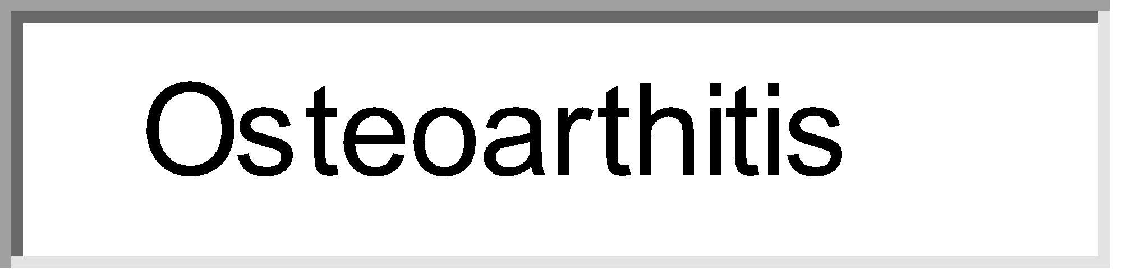
 Osteoarthitis 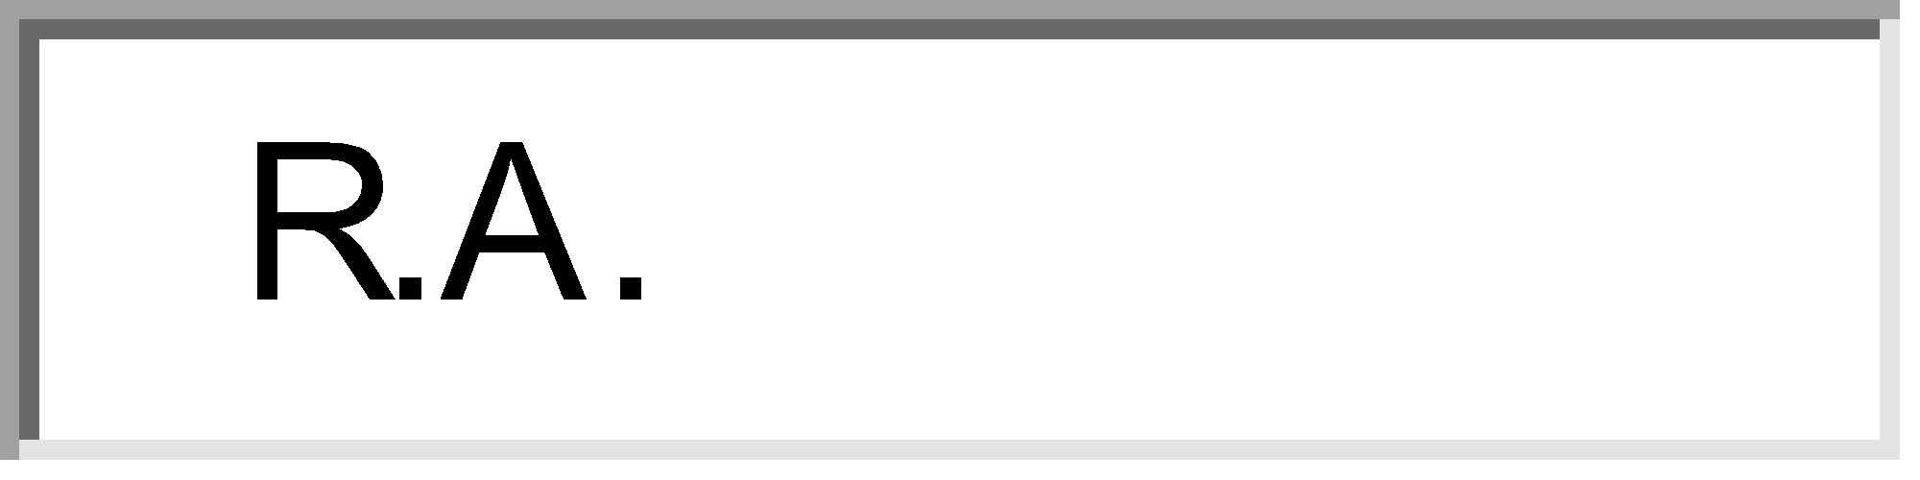
 R.A. 
 Reiter's disease 
 Gonococcal arthritis
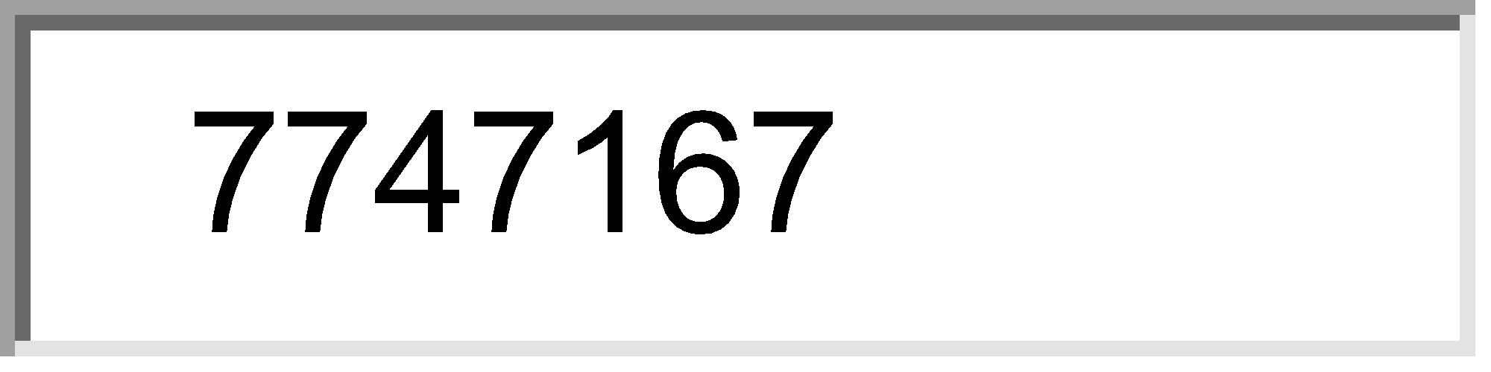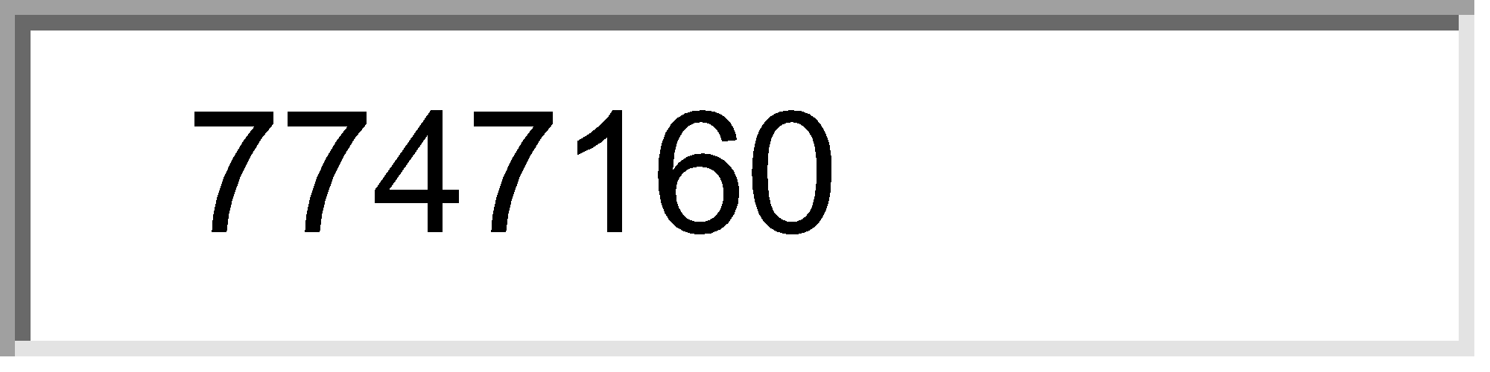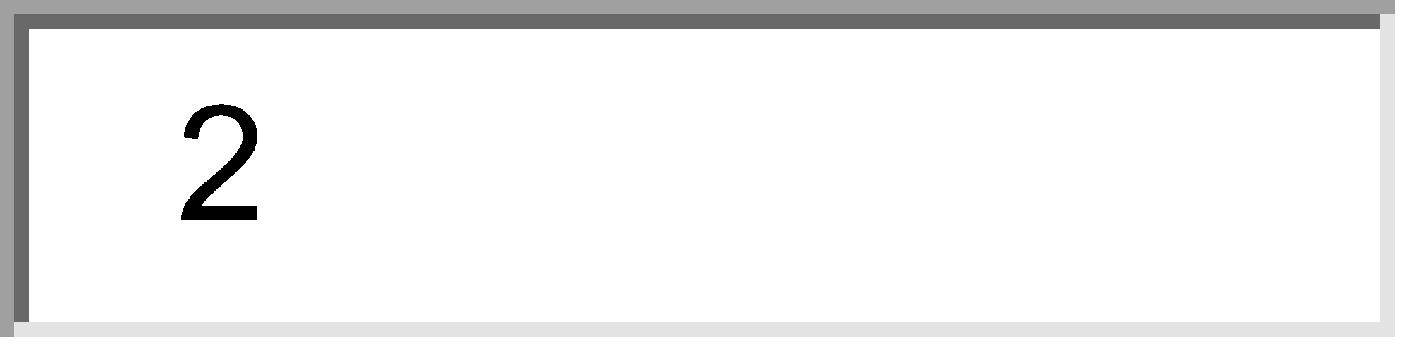

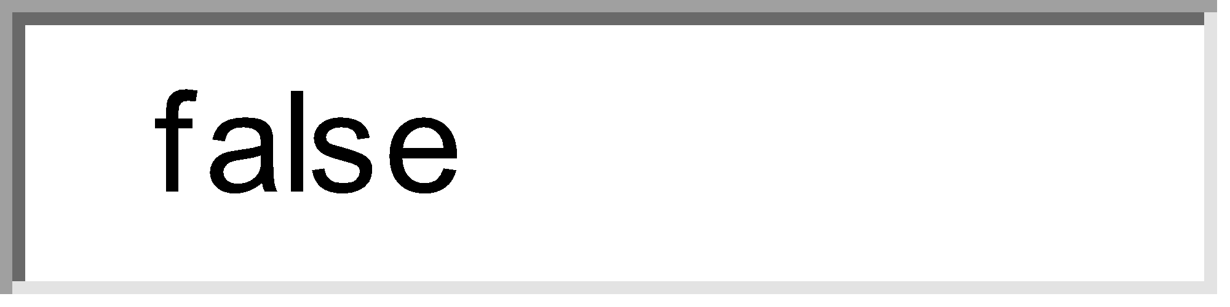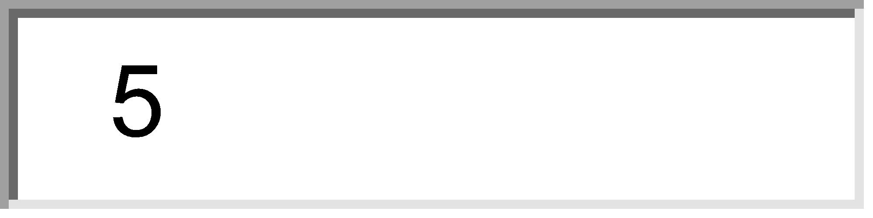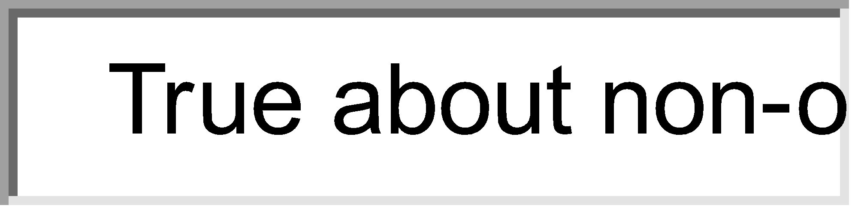

2) True about non-ossifying fibroma of bone :
Choose 3 of the following options. 
 Present until 3rd & 4th decade 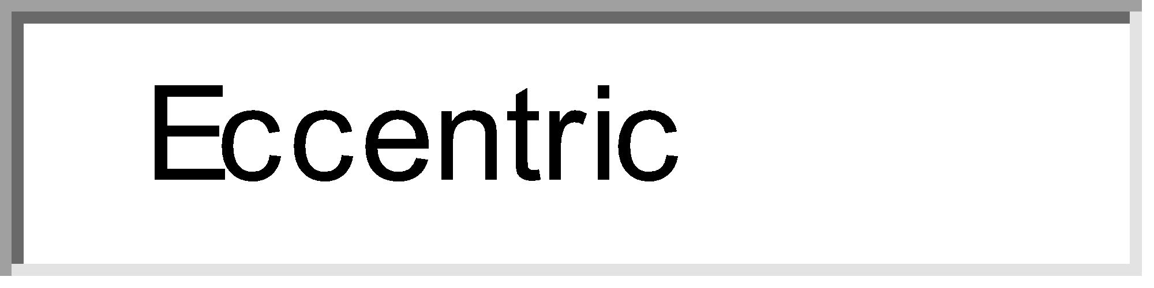
 Eccentric 
 Prominent sclerotic margin 
 Histologically giant cell with areolar tissue 
 Metaphyseal lesion
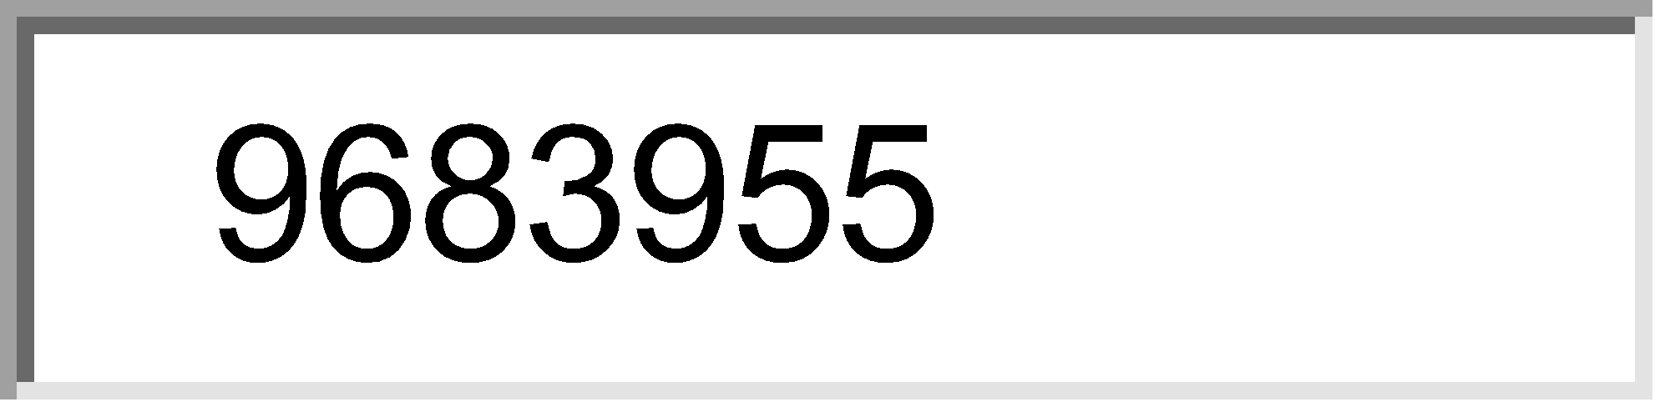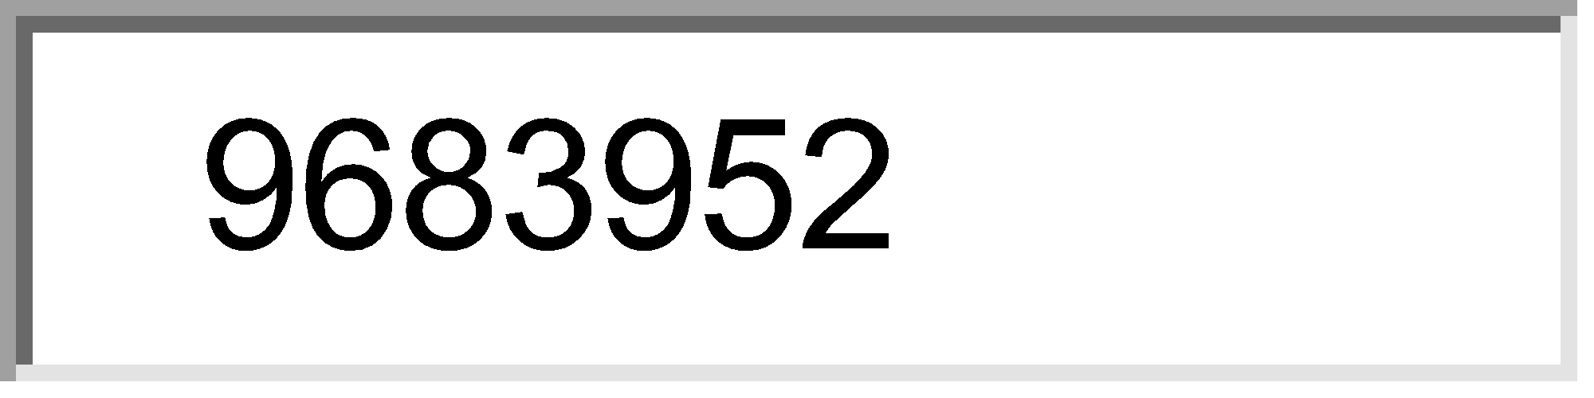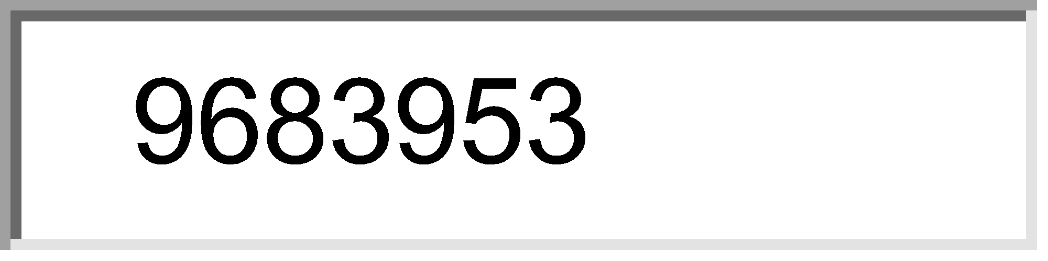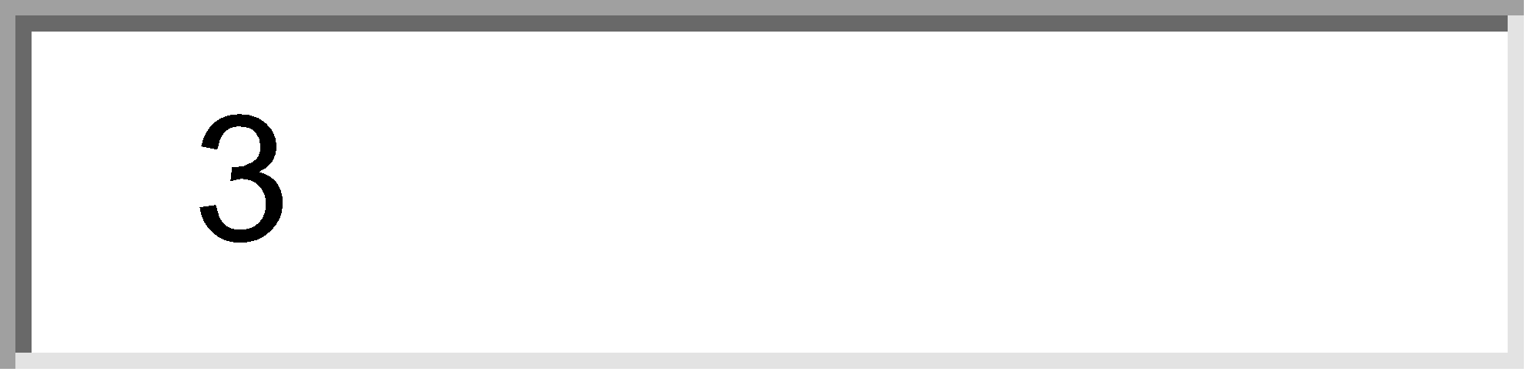



3) Bone forming tumors are:
Choose 3 of the following options. 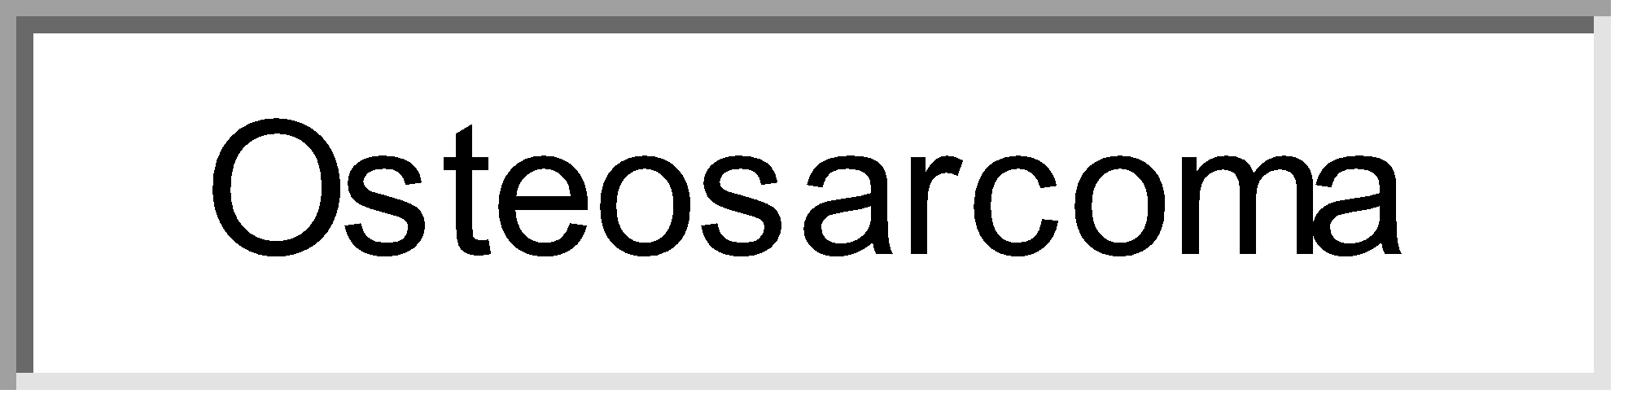
 Osteosarcoma 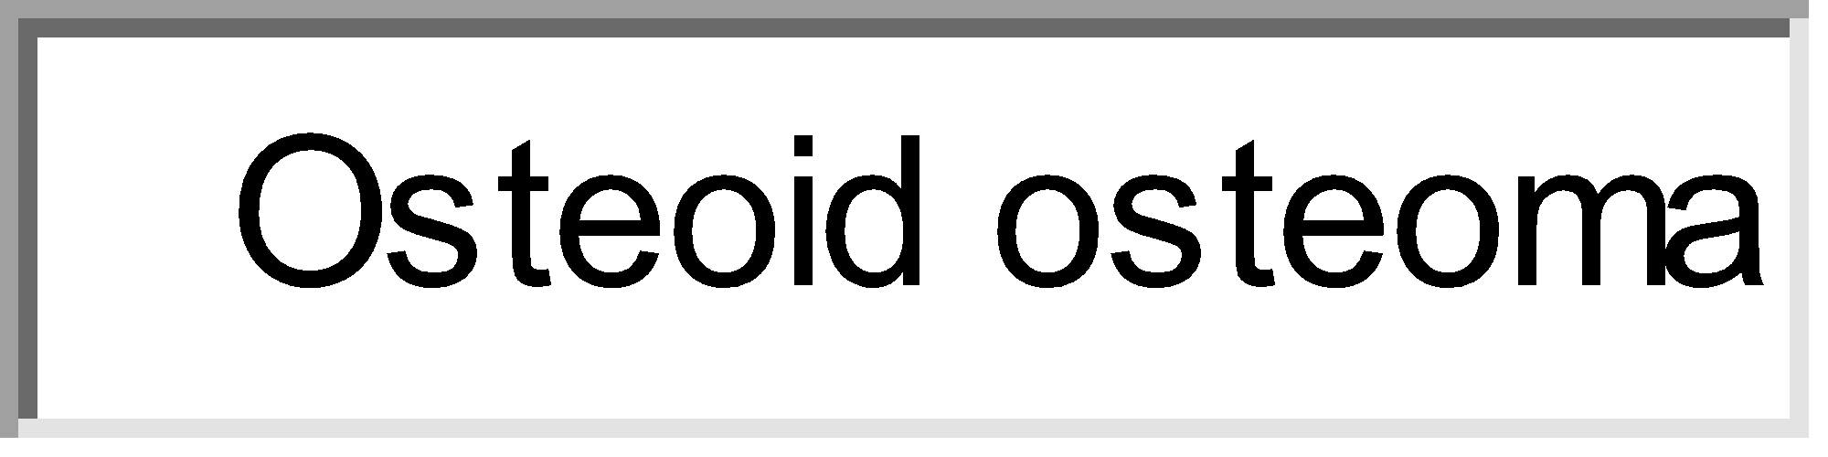
 Osteoid osteoma 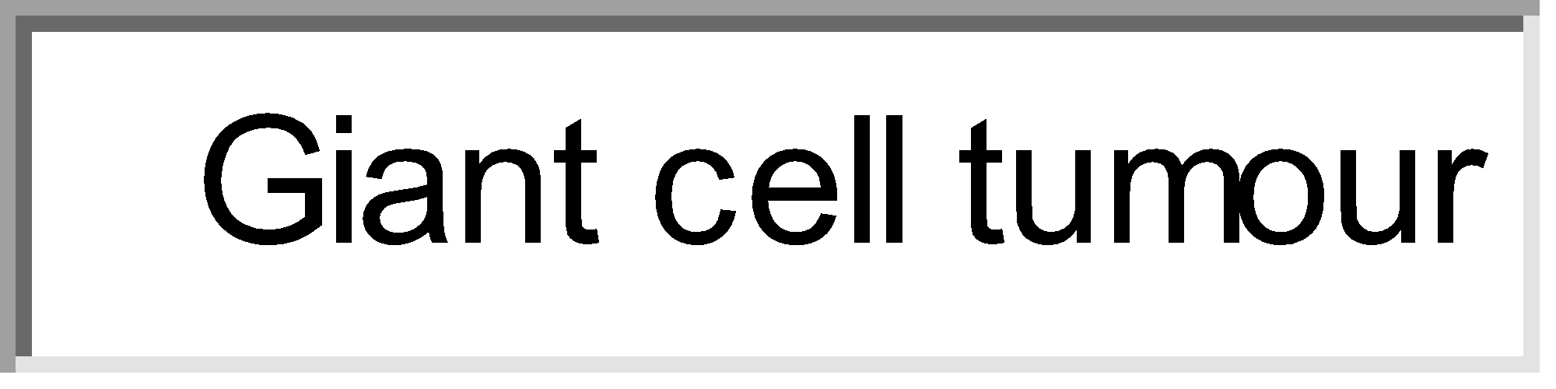
 Giant cell tumour 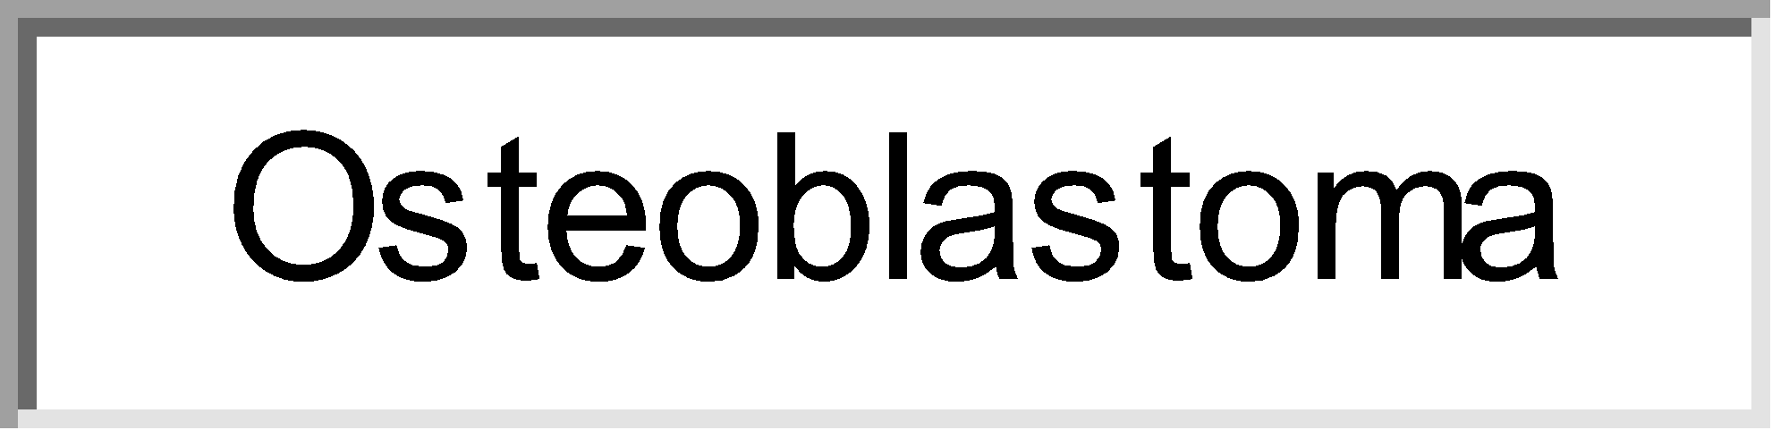
 Osteoblastoma 
 Chondrosarcoma
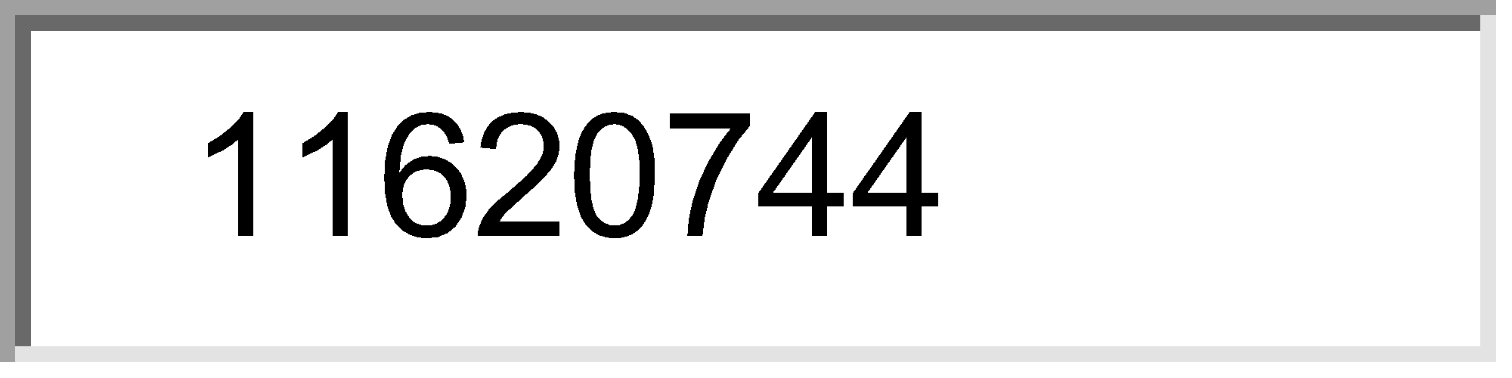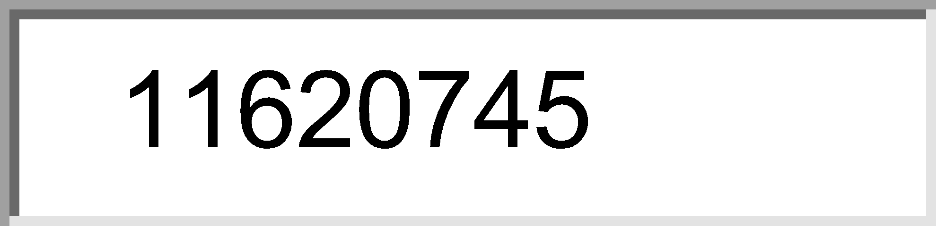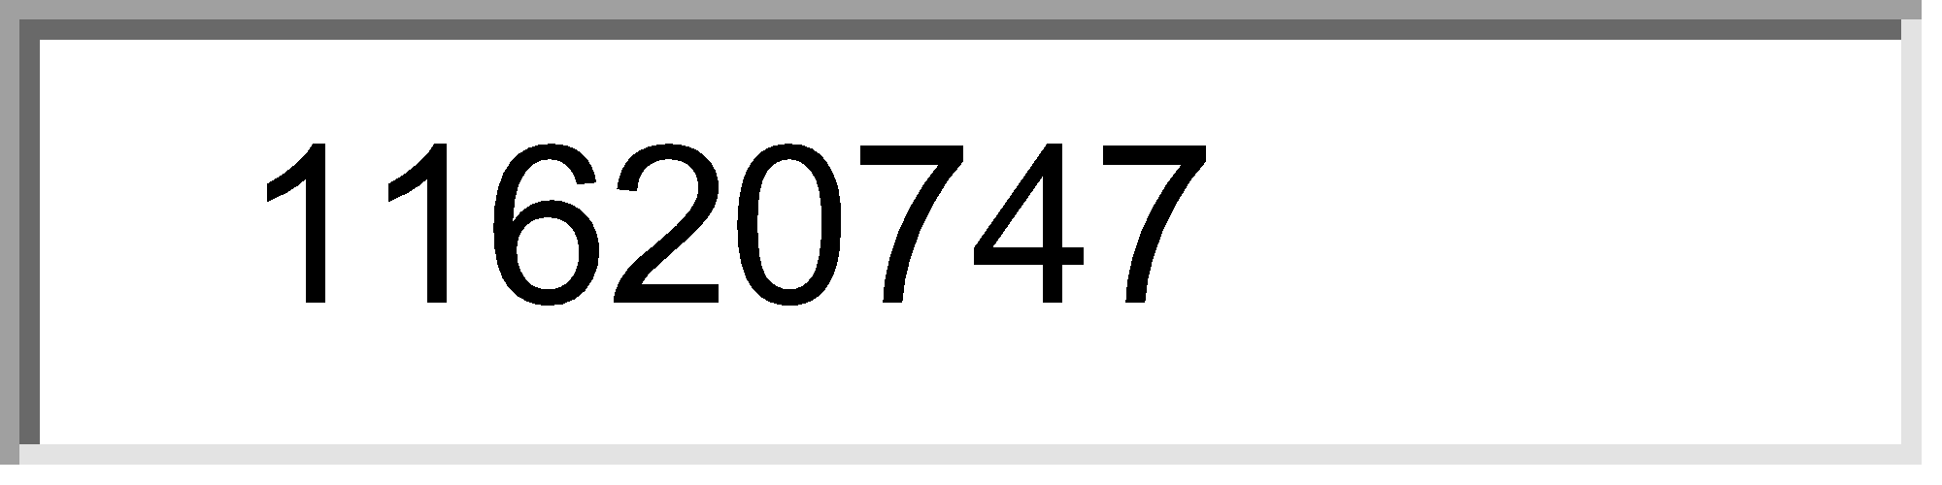



4) True about carpel tunnel syndrome:
Choose 2 of the following options. 
 Paraesthesia of the lateral 2 fingers 
 Atropy of the thenar eminence 
 Atropy of the hypothenar eminence 
 Claw hand 
 Tinel sign is positive
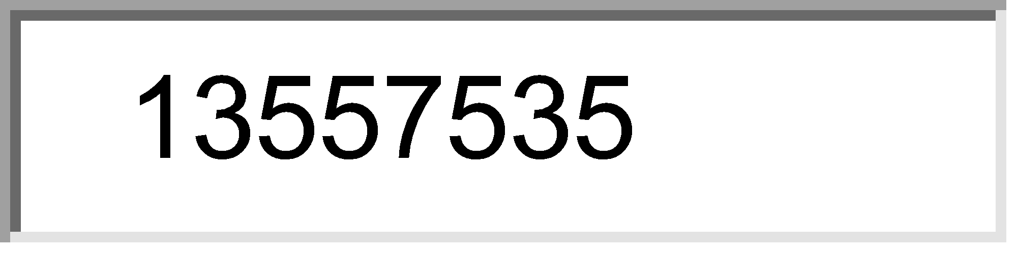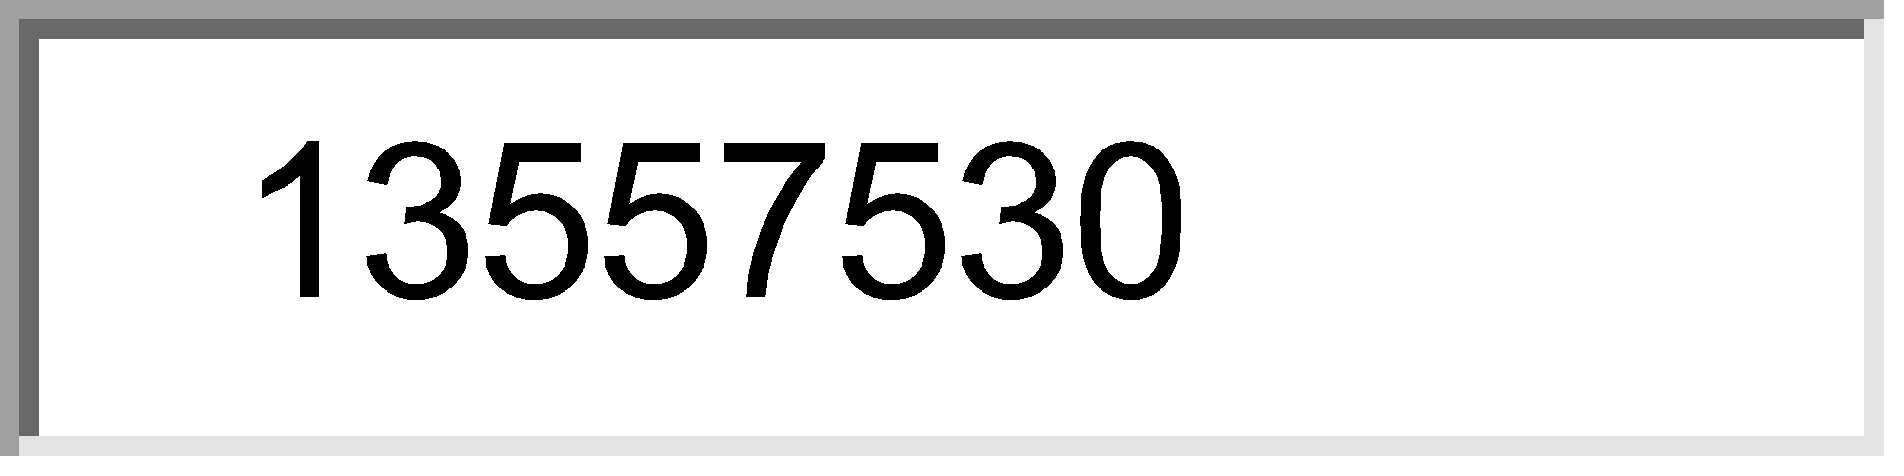



5) Traumatic dislocation of epiphysial plate of femur occurs:
Choose 2 of the following options. 
 Medially 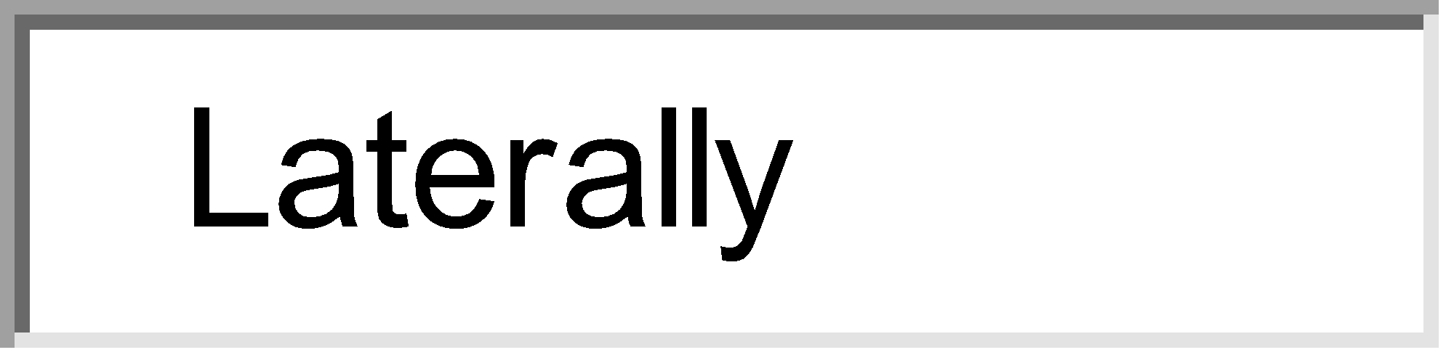
 Laterally 
 Posteriorly 
 Rotationally 
 Anteriorly
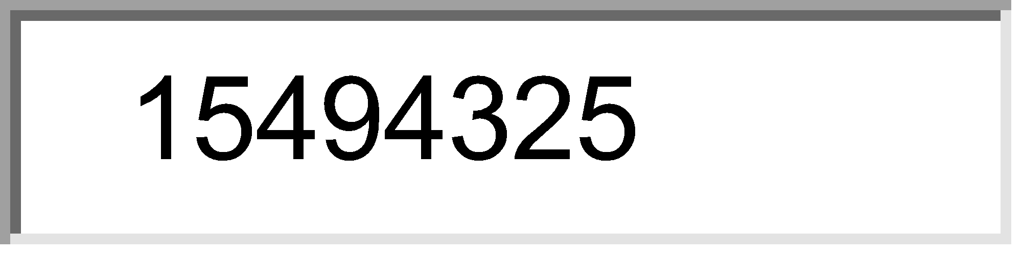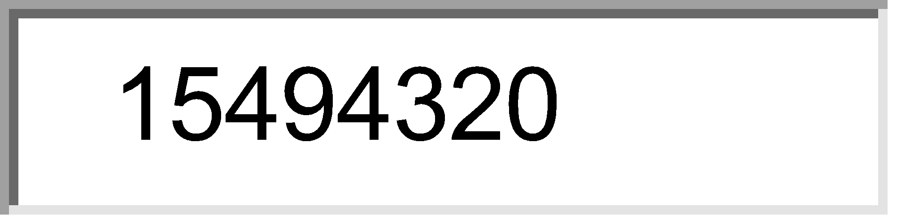

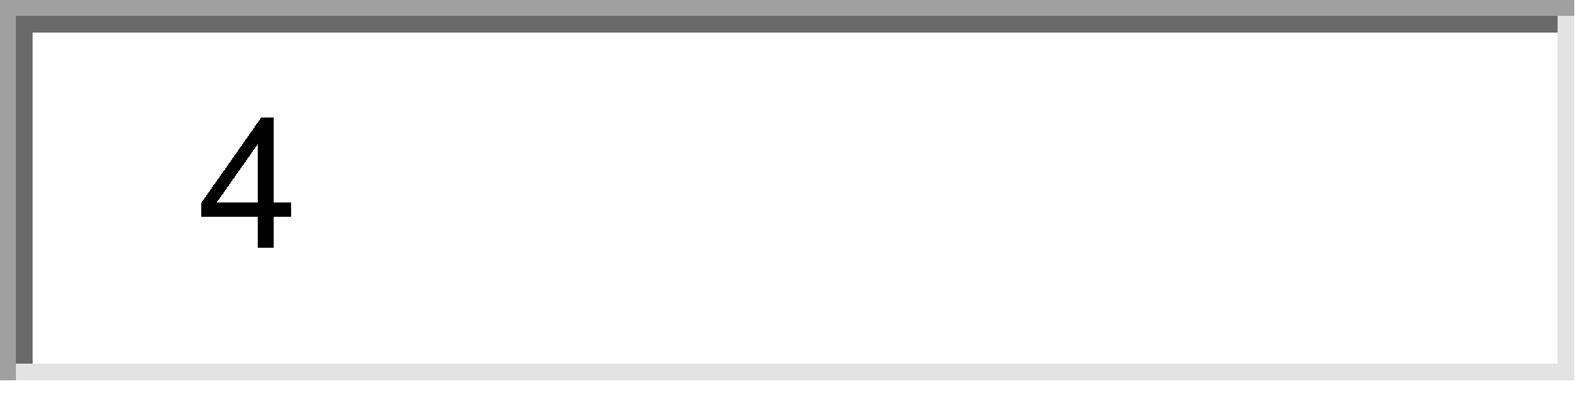

6) Avascular vecrosis is seen in:
Choose 2 of the following options. 
 Sickle cell disease 
 Thalassemia 
 Polycytheinia 
 Hyperparathyroidism
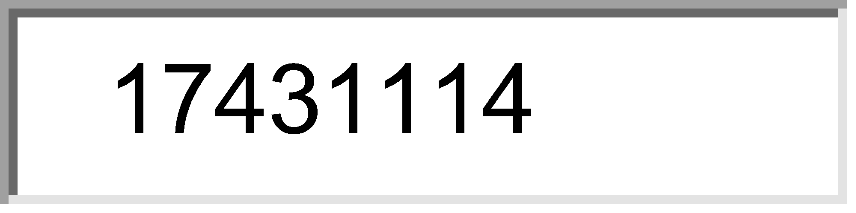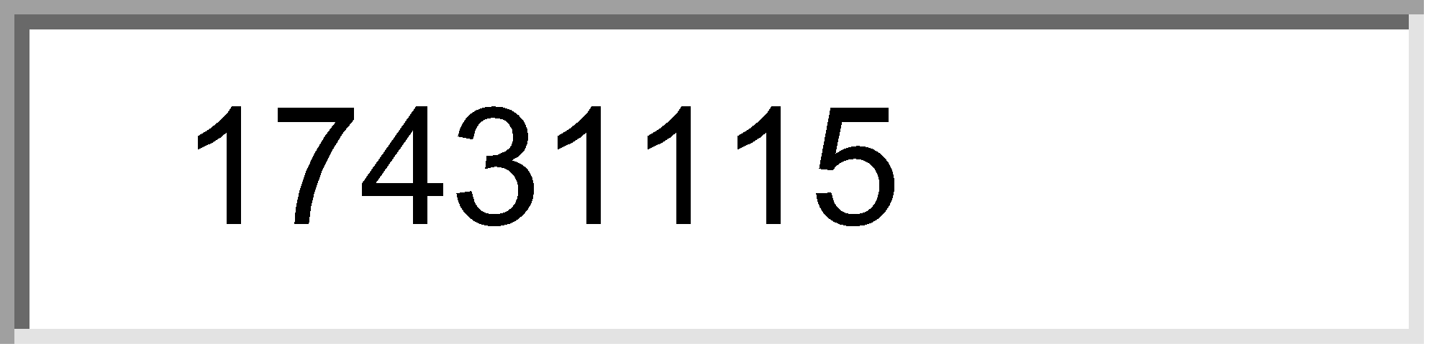



7) Chordoma commonly involves:
Choose 3 of the following options. 
 Dorsal spine 
 Clivus 
 Lumber spine 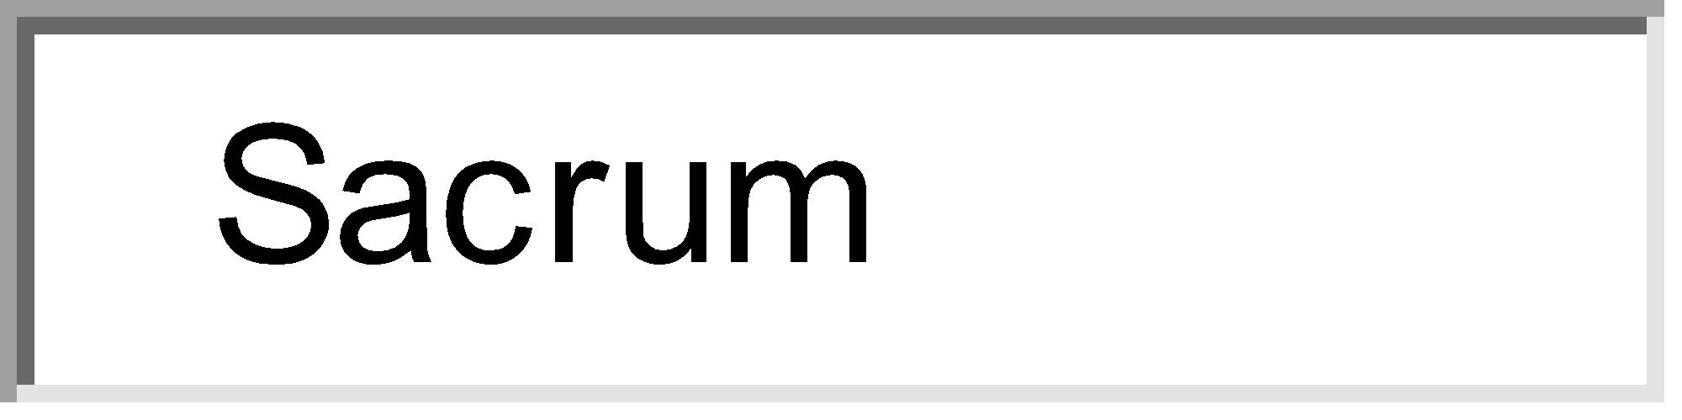
 Sacrum 
 Cervical spine
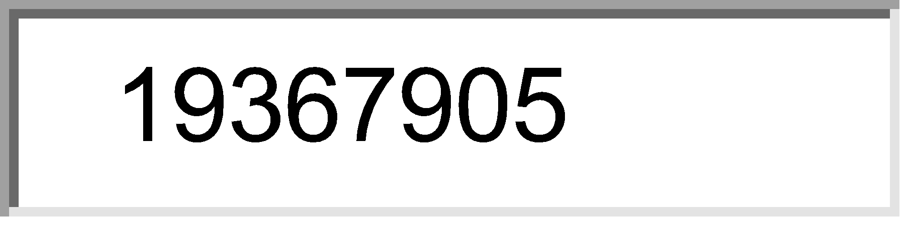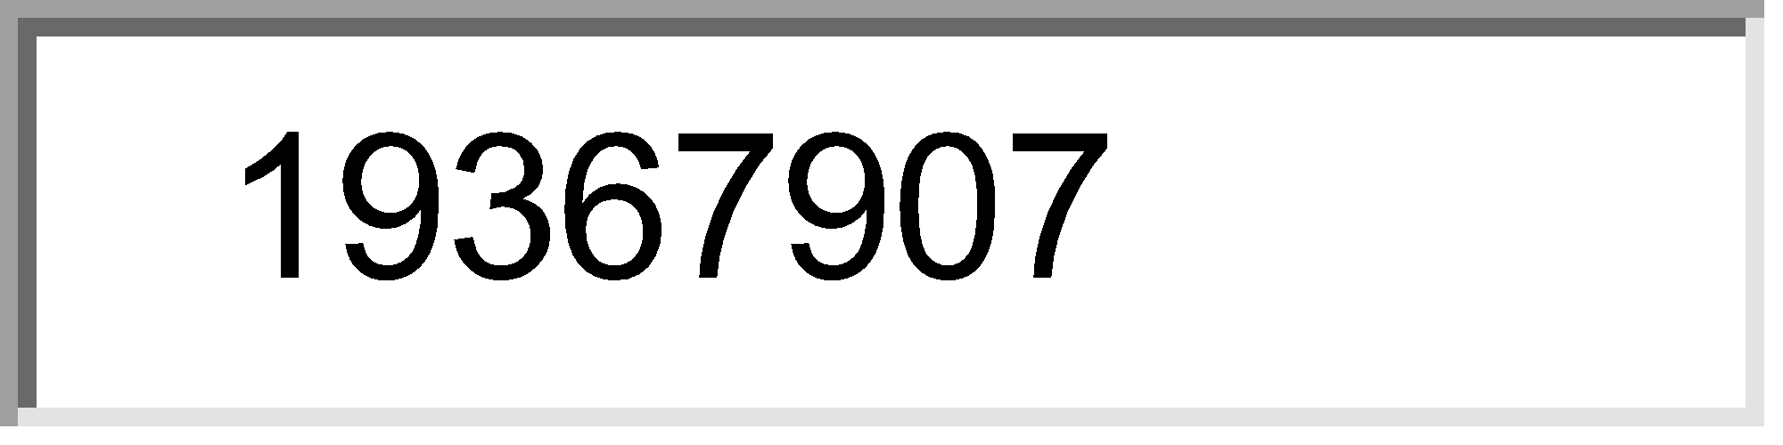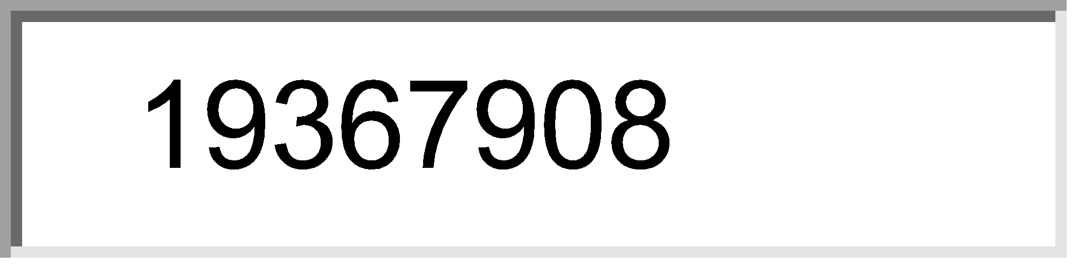



8) True regarding acute osteomyelitis in a child :
Choose 3 of the following options. 
 Diagnosis by X-ray is 8-10 days after onset 
 There is diffuse tenderness at the site 
 Antibiotic therapy sould be at least for 4 weeks 
 Salmonella is the most common cause
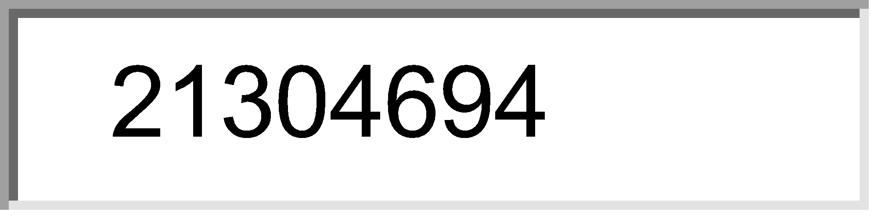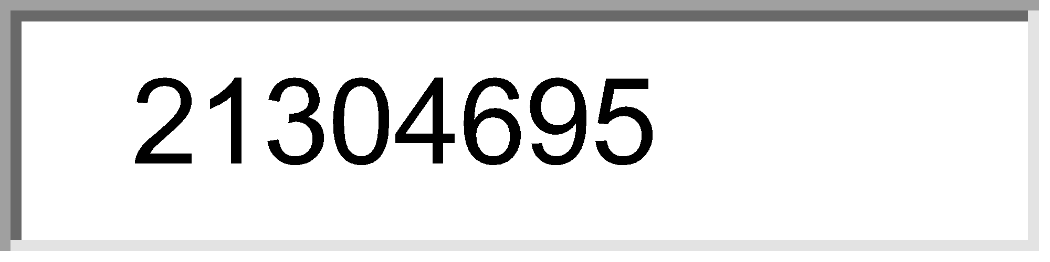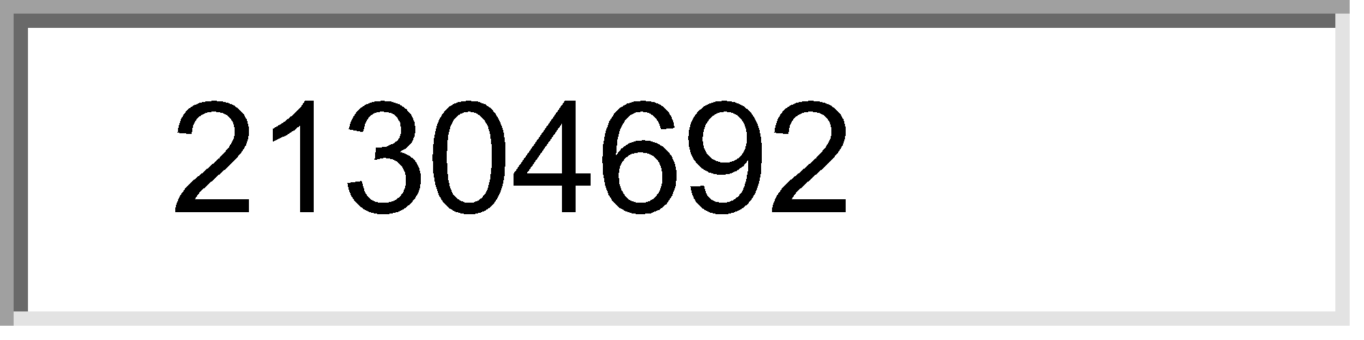



9) Mallet finger is due to avulsion of extensor tendon of:
One answer only. 
 Proximal phalanx 
 Middle Phalanx 
 Distal Phalanx 
 Metacarpals 
 Any other phalanx
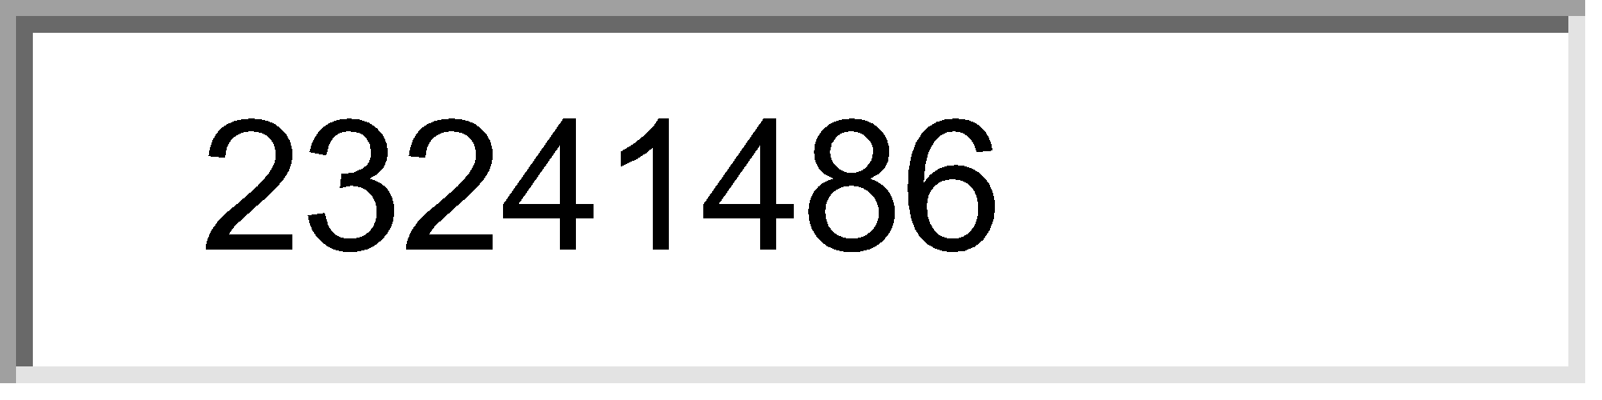



10) Osgood Schlatters disease affects:
One answer only. 
 Upper tibia 
 Lower tibia 
 distal femur 
 Proximal femur 
 Patella
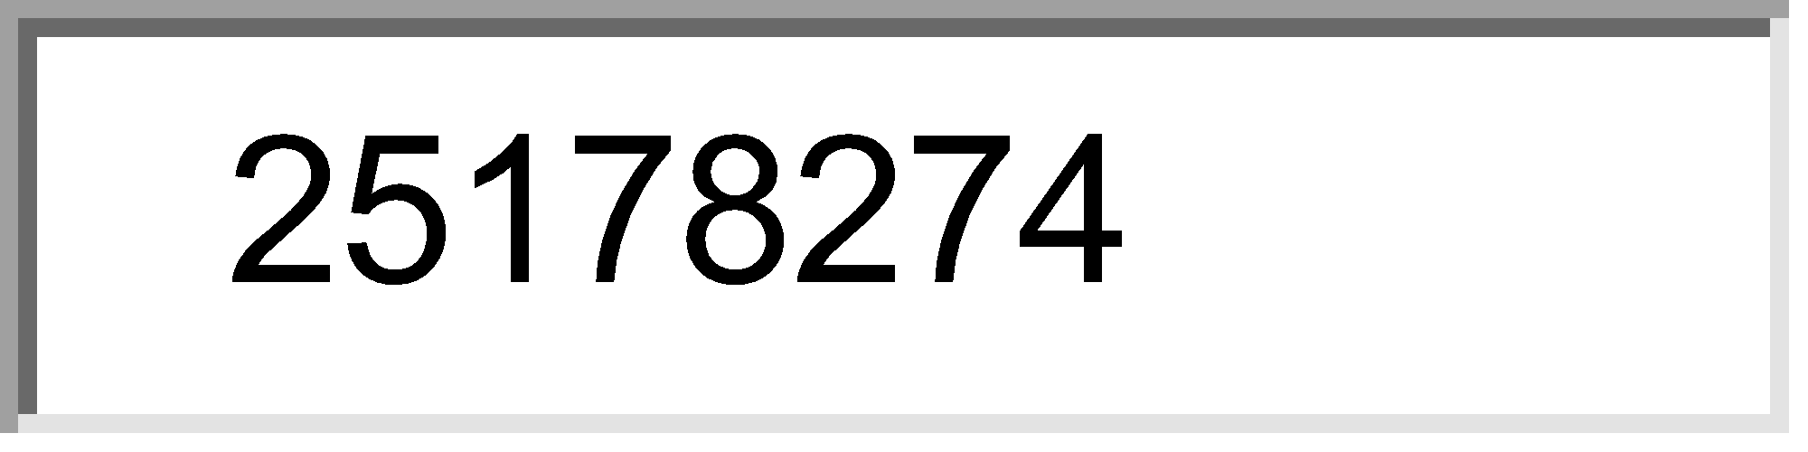



11) Seen in B/L congenital hip dislocation is/are :
Choose 3 of the following options. 
 Short Strature 
 Wandering acetabulum 
 Waddling gait 
 Lumbar lordosis
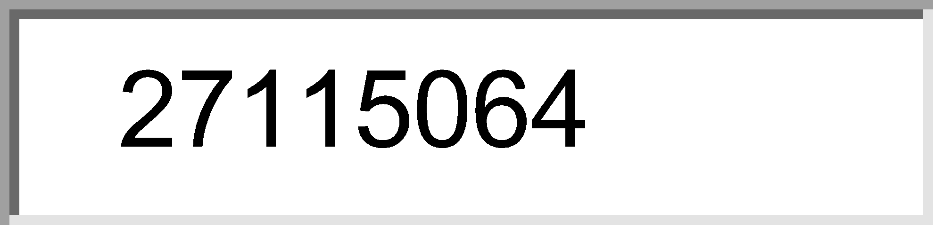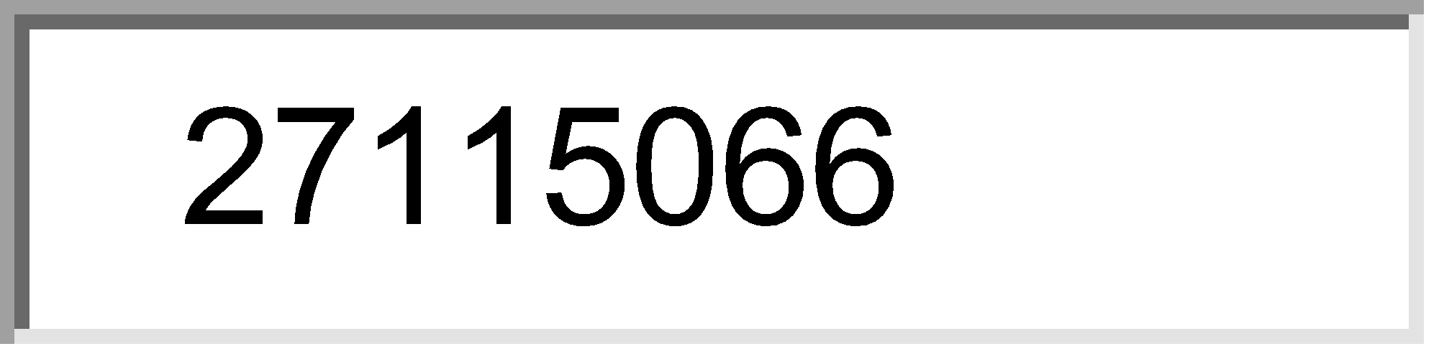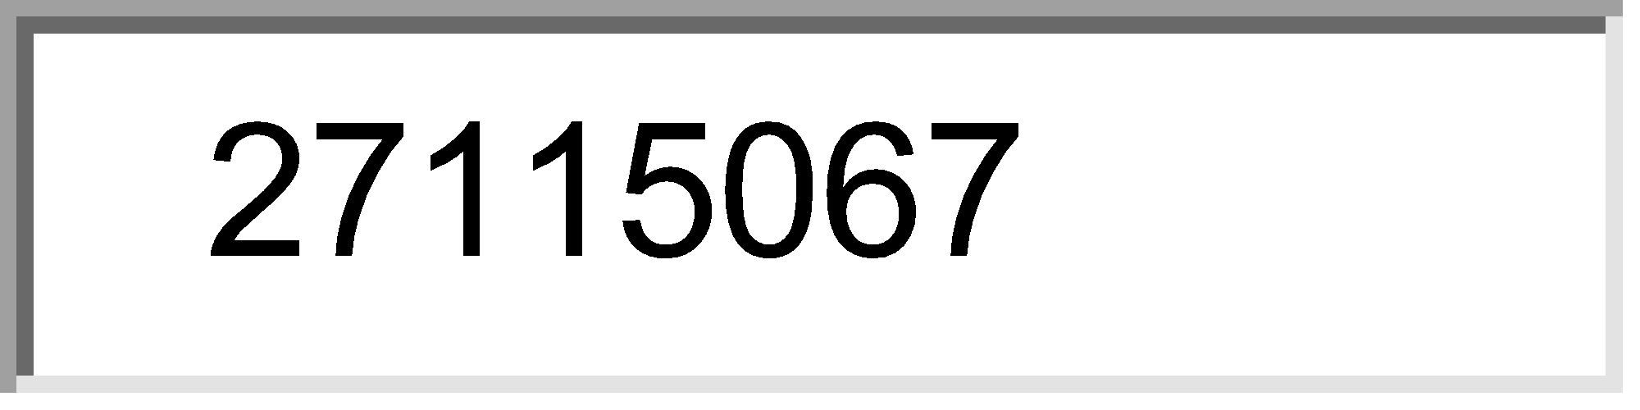



12) Trendelenberg test is done for :
Choose 2 of the following options. 
 Perforators 
 Saphenofemoral junction incompetence 
 DVT 
 Pulmonary embolism
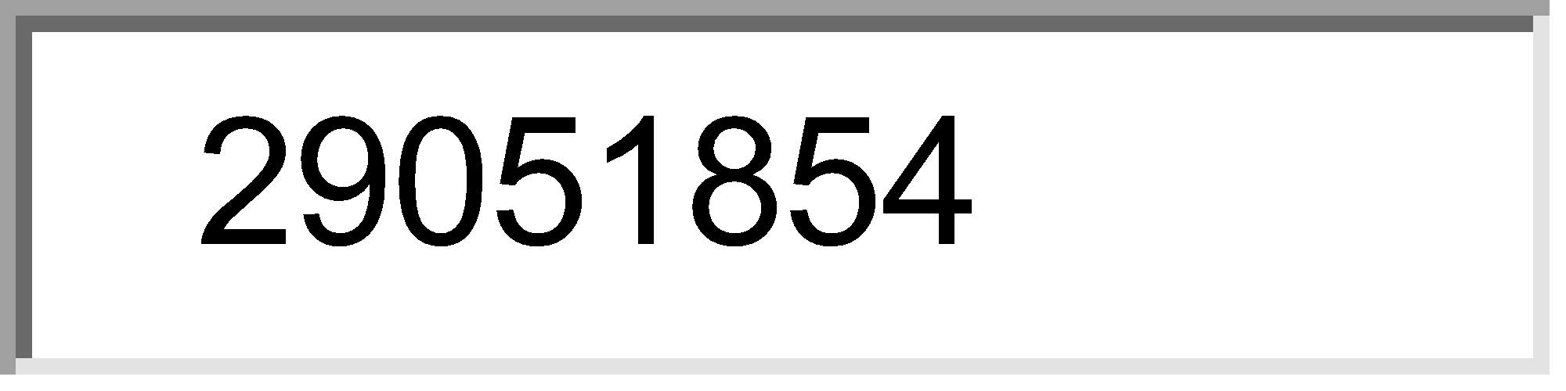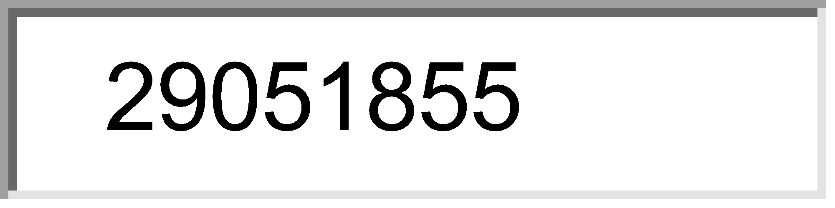



13) Treatment of # with intraarticular extension is/are A/E :
One answer only. 
 Excision of the joint 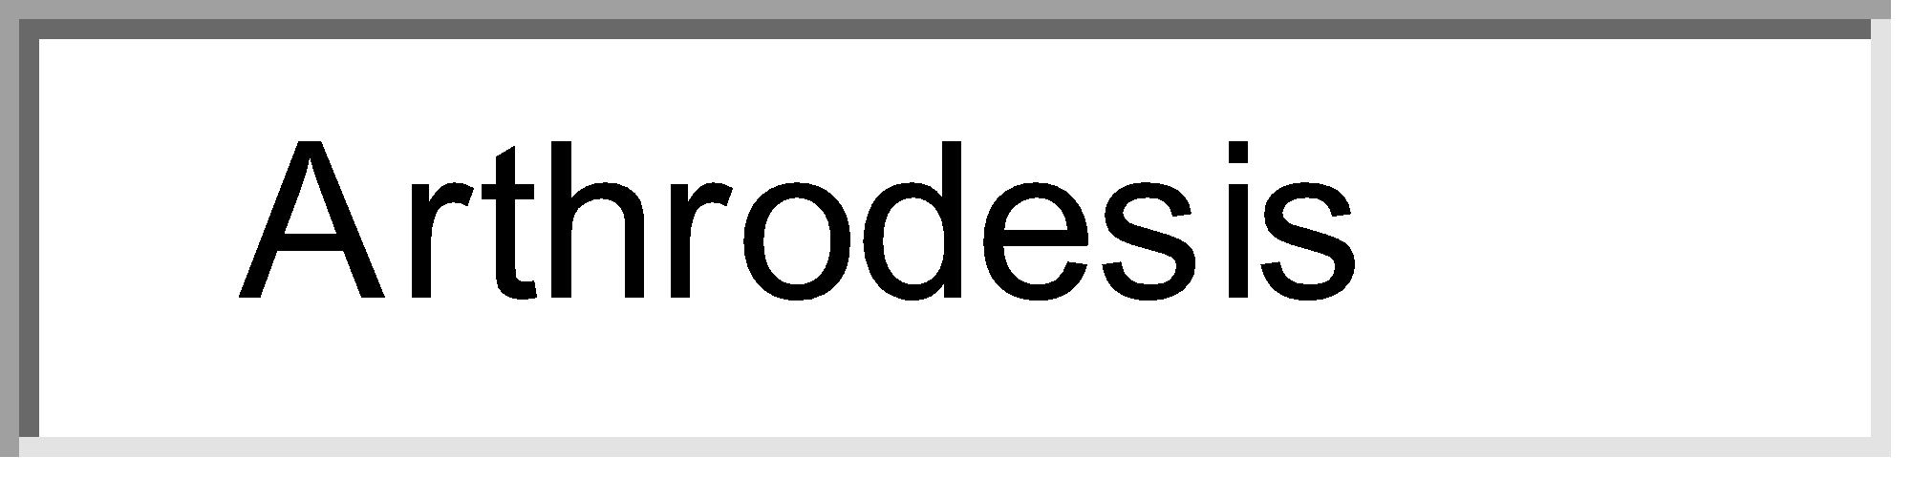
 Arthrodesis 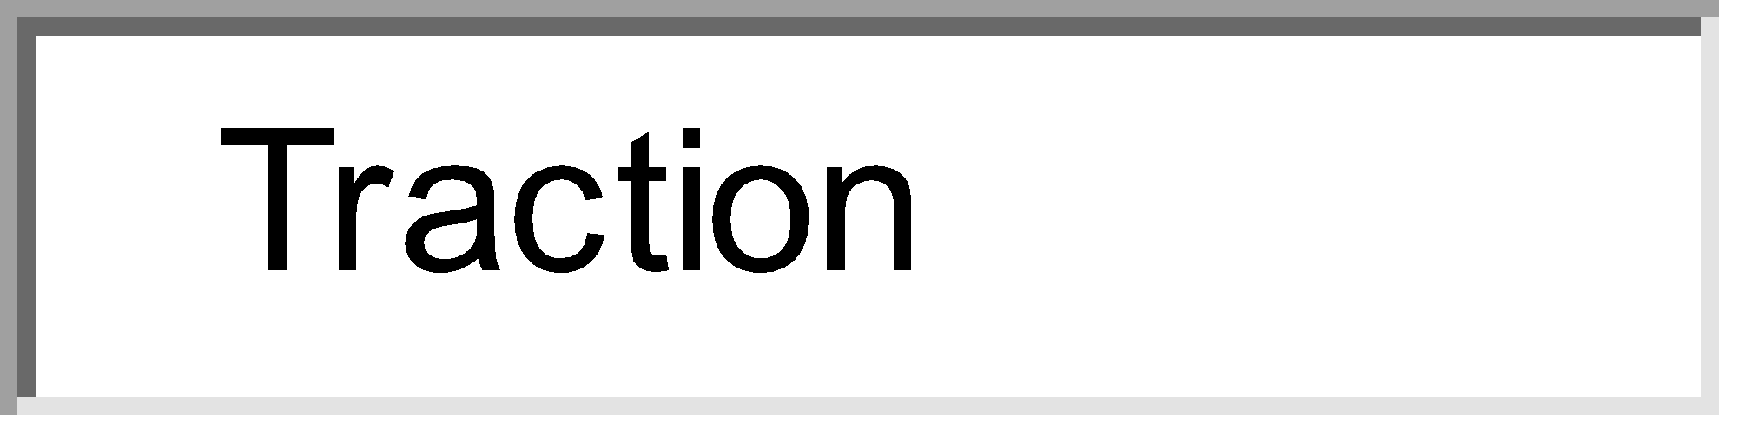
 Traction 
 Intramedullary nailing 
 POP
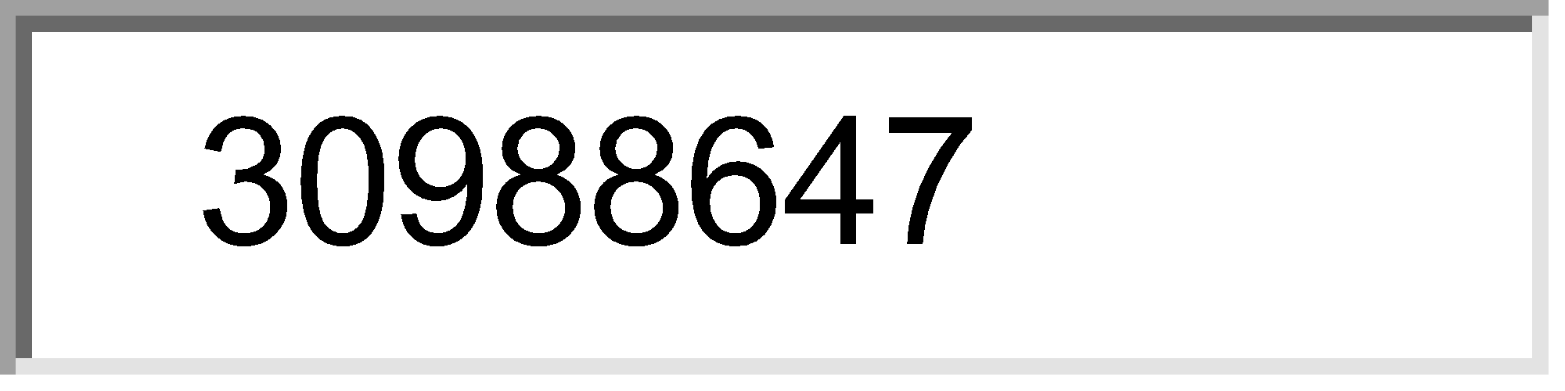



14) Tophi in gout are seen in a/e :
One answer only. 
 Articular cartilage 
 Joint capsule 
 Synovium 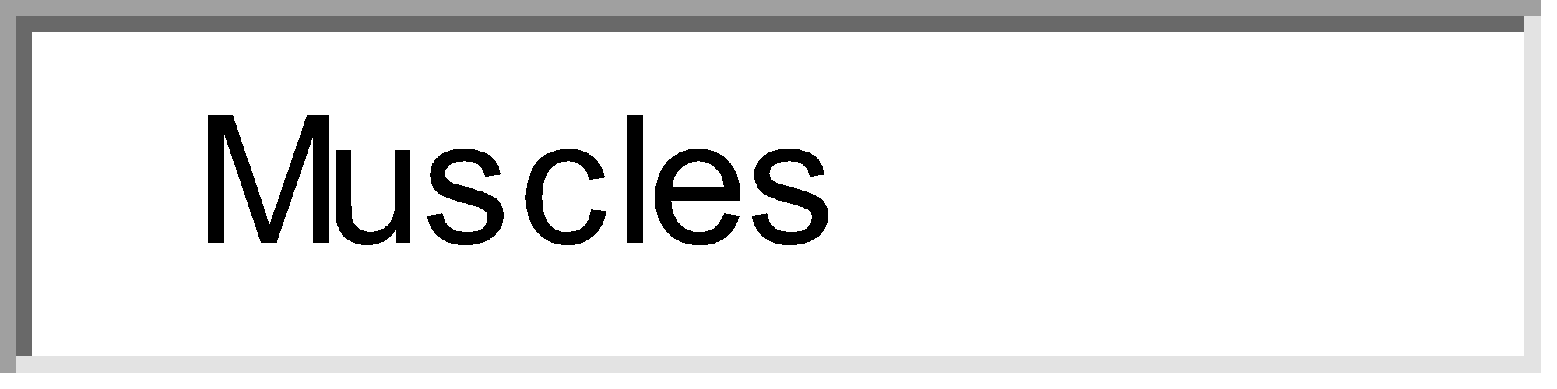
 Muscles 
 Skin
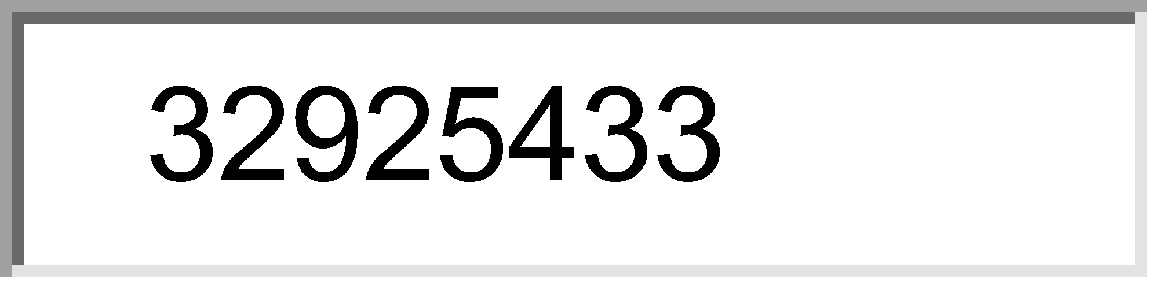



15) Paget's disease of bone commonly affects :
Choose 3 of the following options. 
 Skull 
 Vertabra 
 Plevis 
 Phalanges 
 Humerus
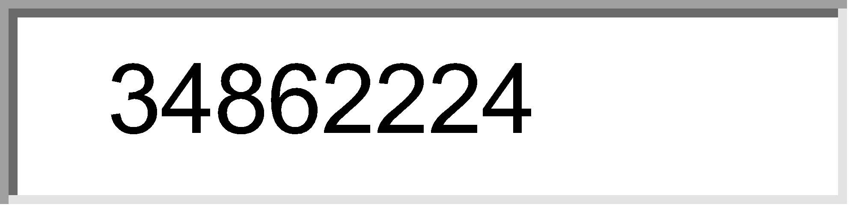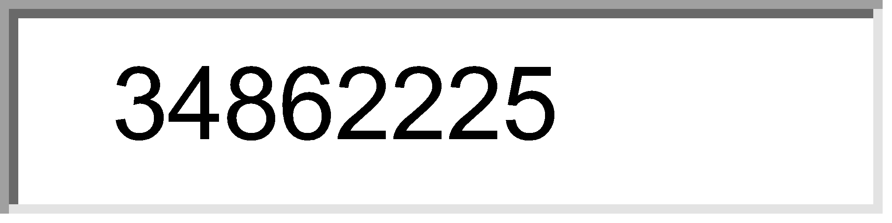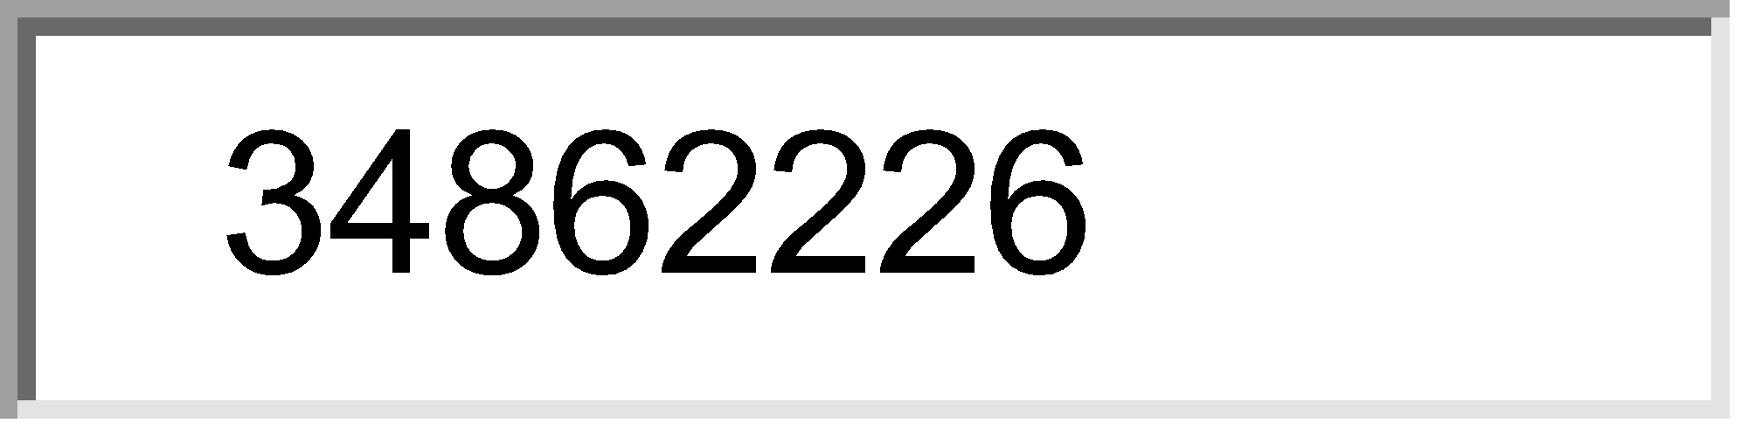



16) True about Ewing's sarcoma is all except :
Choose 2 of the following options. 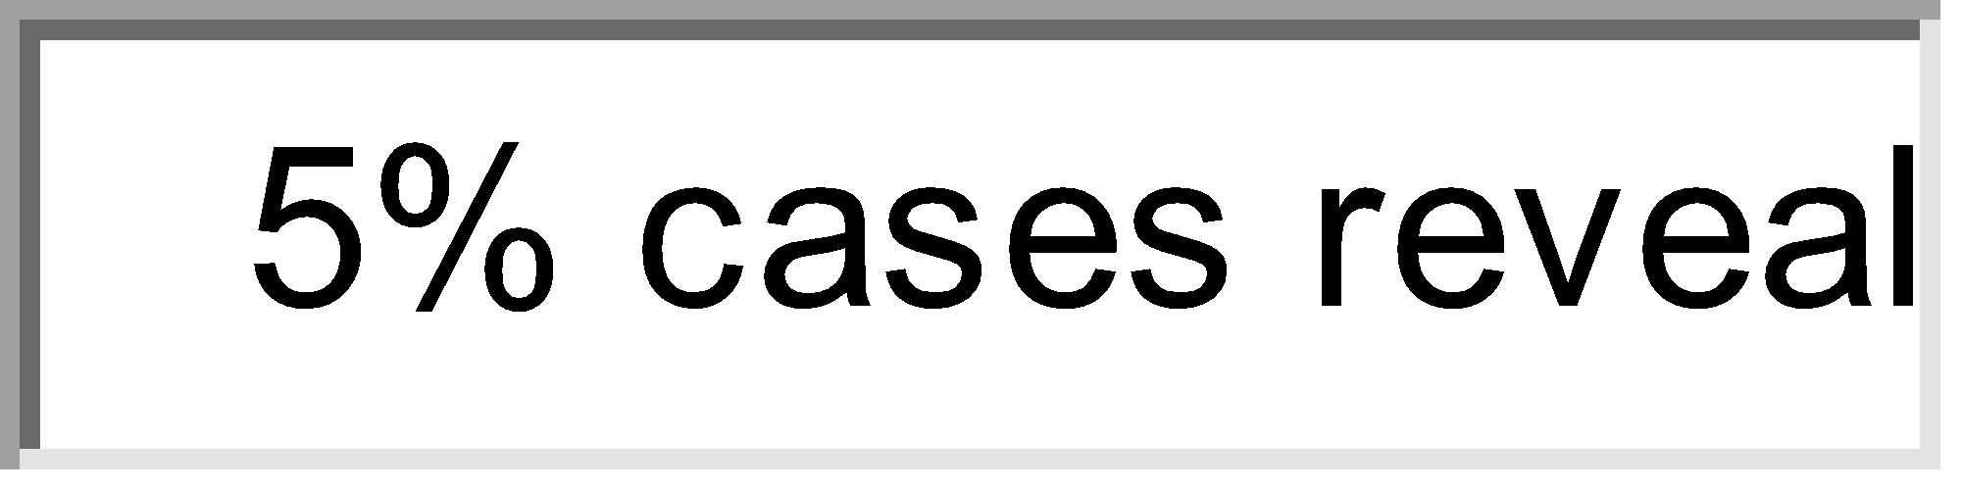
 5% cases reveals t(11-22) 
 Arise from medullary cavity of tubular bone 
 Arise from diaphysis 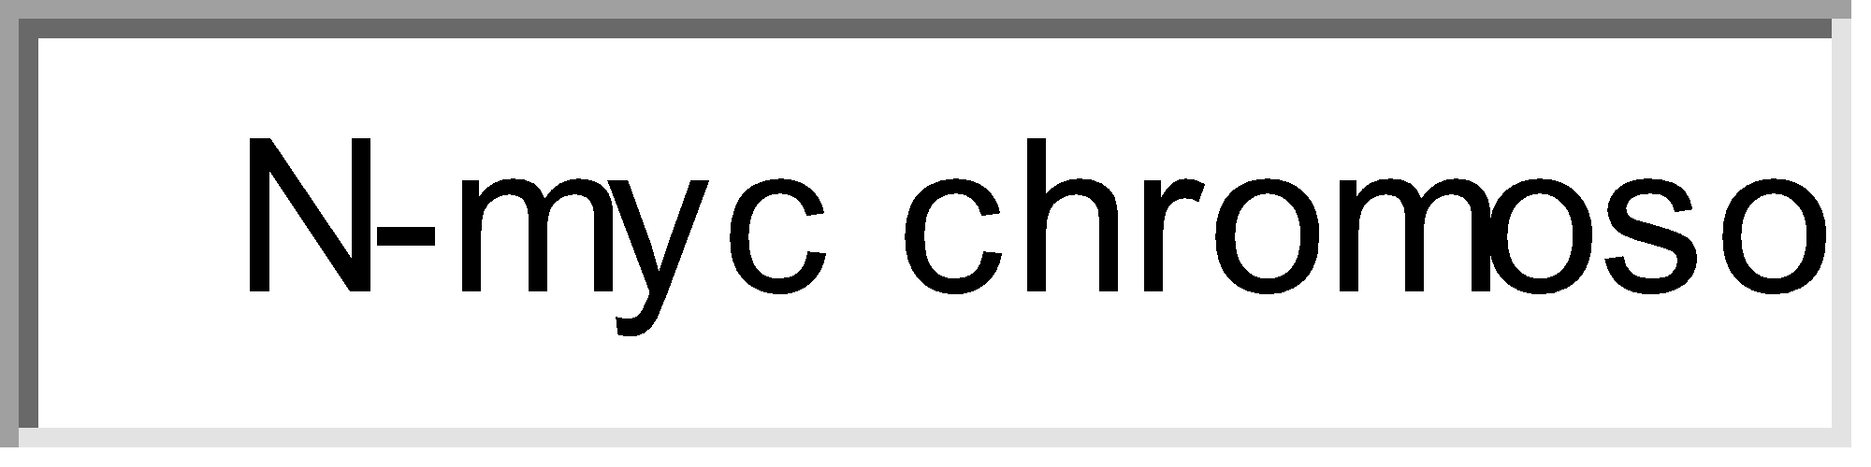
 N-myc chromosome
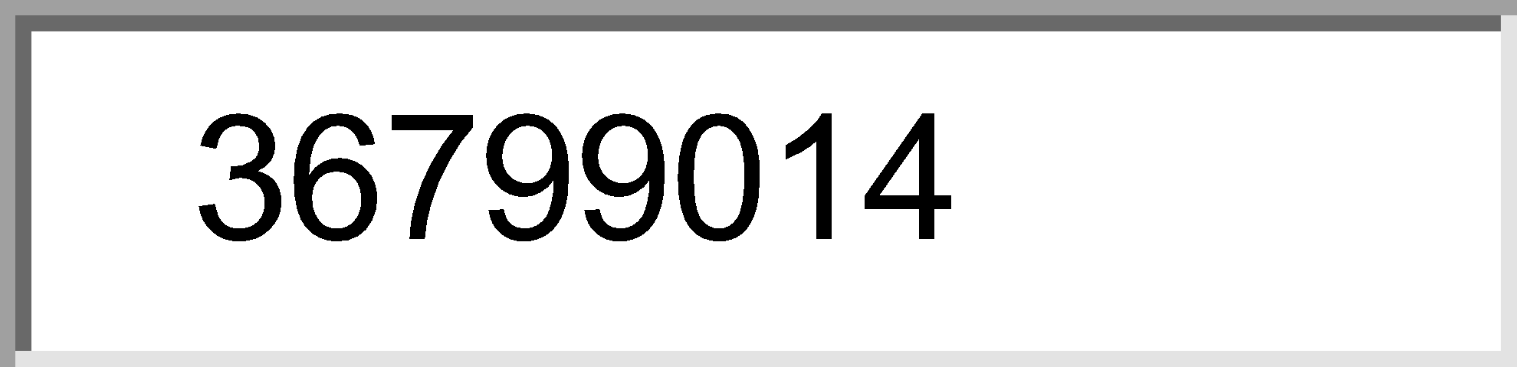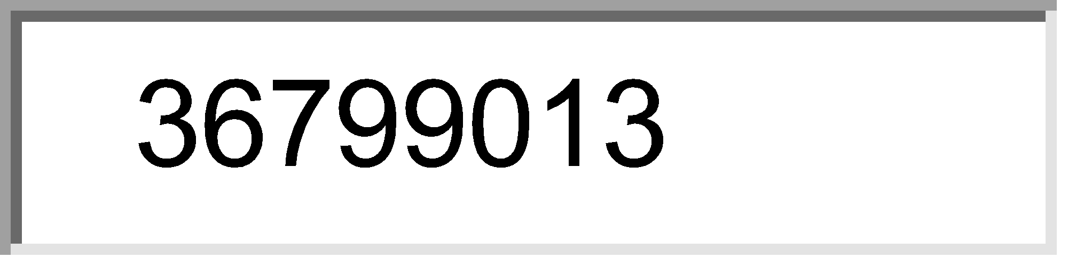



17) Blount's disease is :
One answer only. 
 Genu valgus 
 Tibia vera 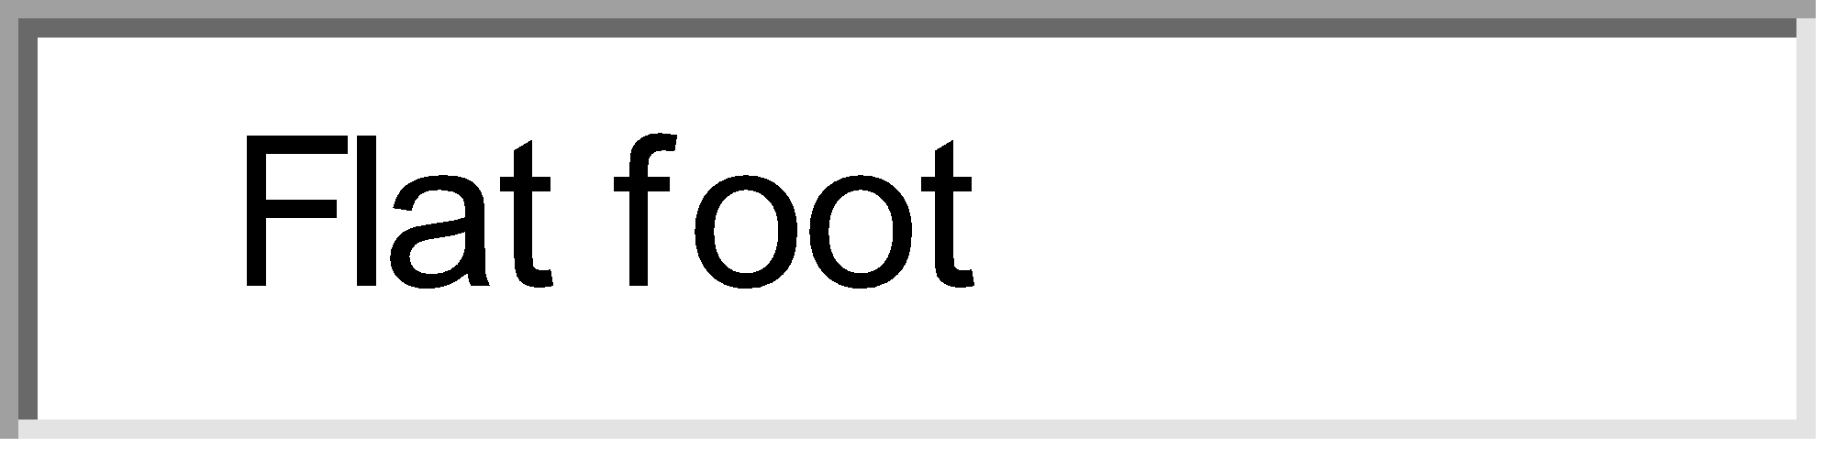
 Flat foot 
 Genu recurvatum
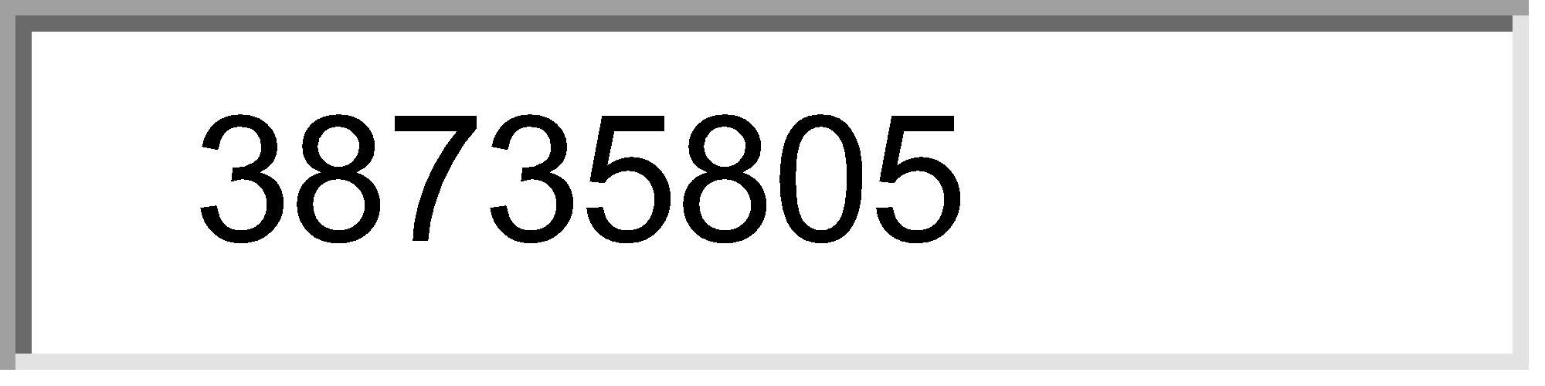



18) Shepherd crook's deformity is seen is :
One answer only. 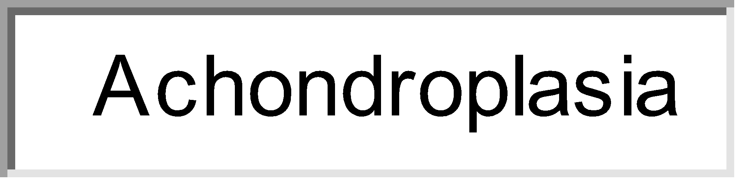
 Achondroplasia 
 Gaucher's disease 
 Hypothyroidism 
 Fibrous dysplasis
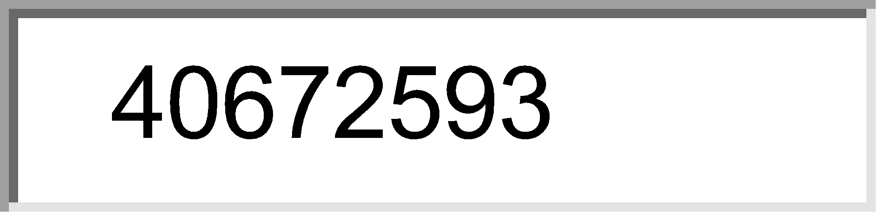



19) MC cause of genu valgum is :
One answer only. 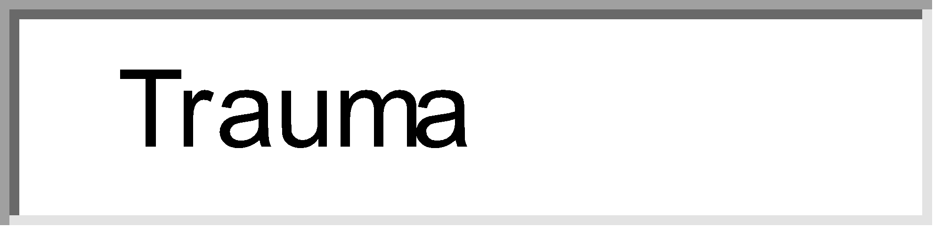
 Trauma 
 Rickets 
 Polio 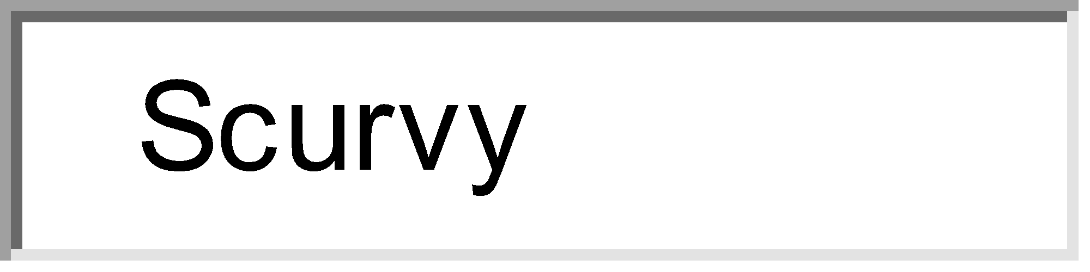
 Scurvy
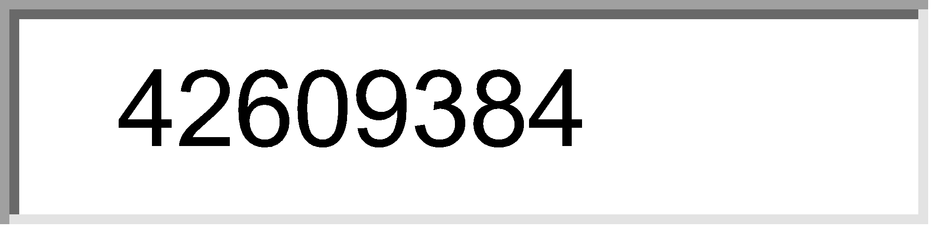



20) Pointing finger is seen in :
One answer only. 
 Ulnar N palsy 
 Median N palsy 
 Ulnar and median N palsy 
 Radial N palsy
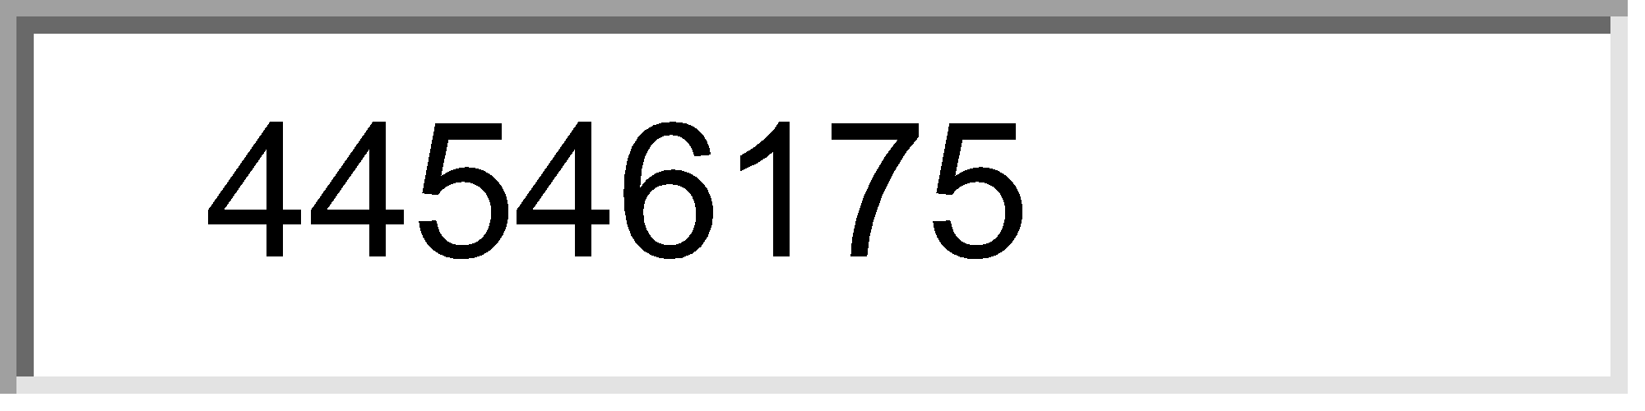



21) Onion peel appearance is seen in :
One answer only. 
 Osteosarcoma 
 Ewings sarcoma 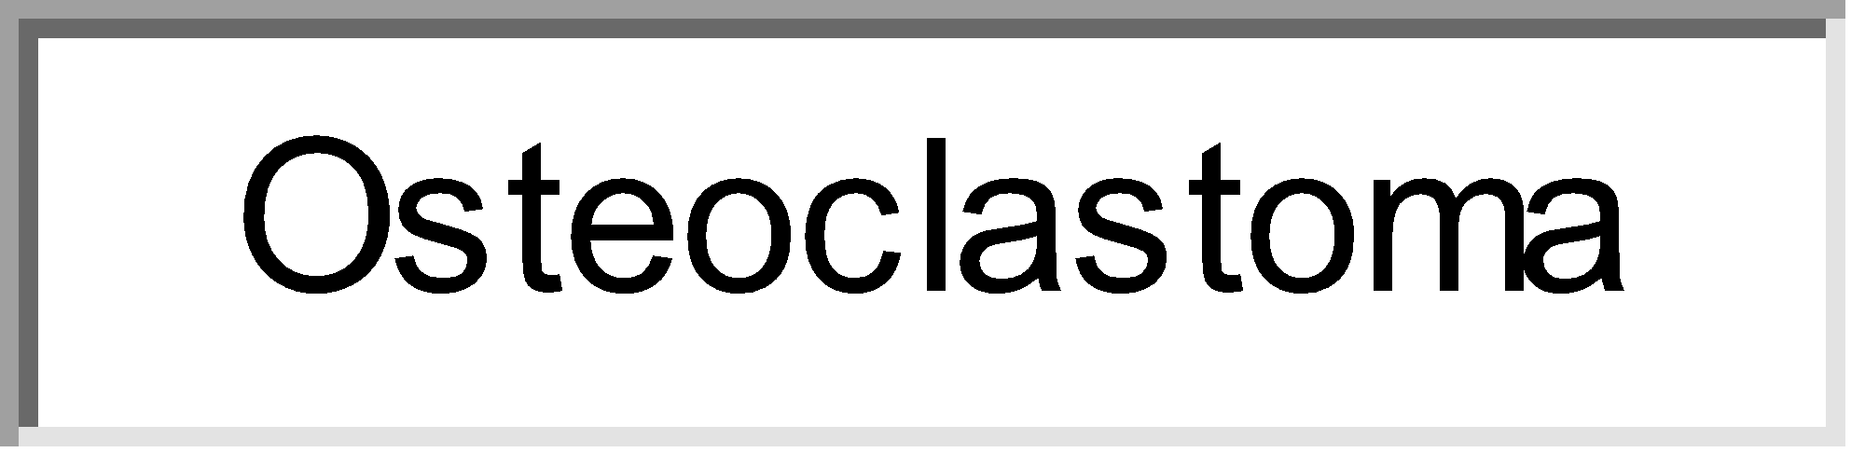
 Osteoclastoma 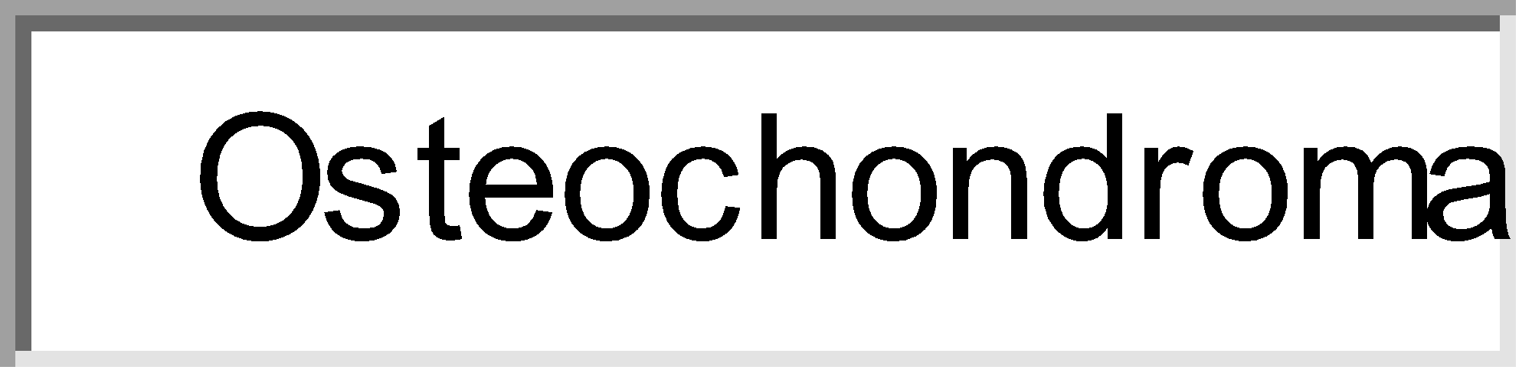
 Osteochondroma
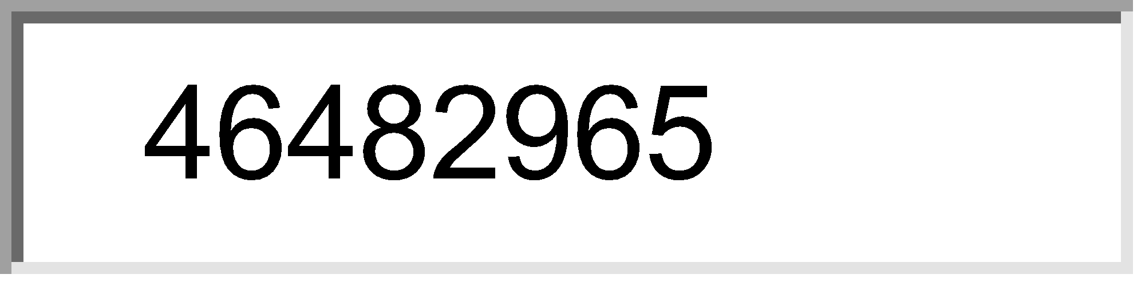



22) Progressive stiffening of a joint is seen in :
One answer only. 
 Peri-arthritis of shoulder 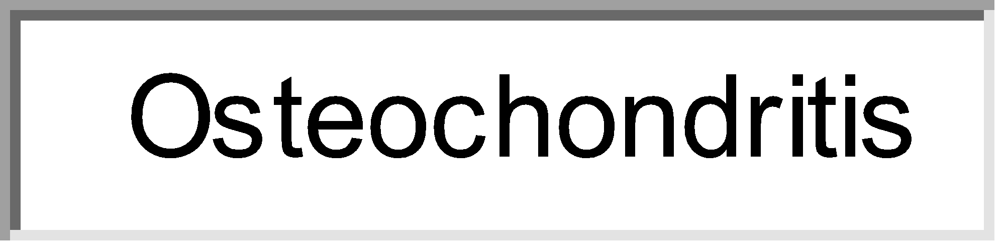
 Osteochondritis 
 Gout 
 Ankylosis
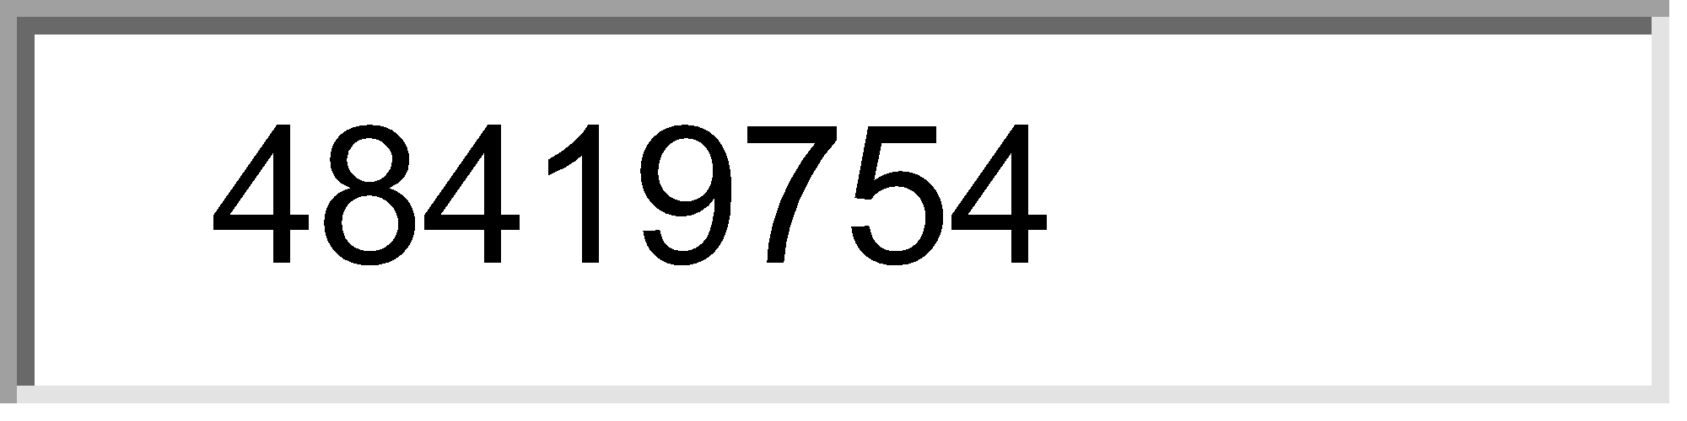



23) Calcification of intervertebral disc occurs in :
Choose 2 of the following options. 
 Ankylosing spondylitis 
 Alkaptonuria 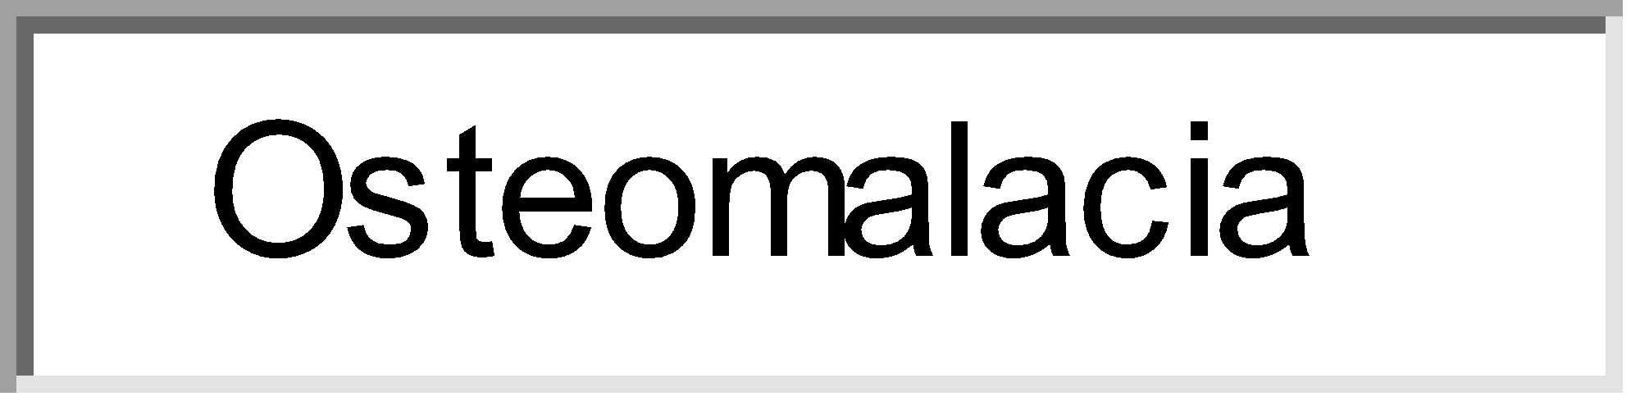
 Osteomalacia 
 Neurofibroma
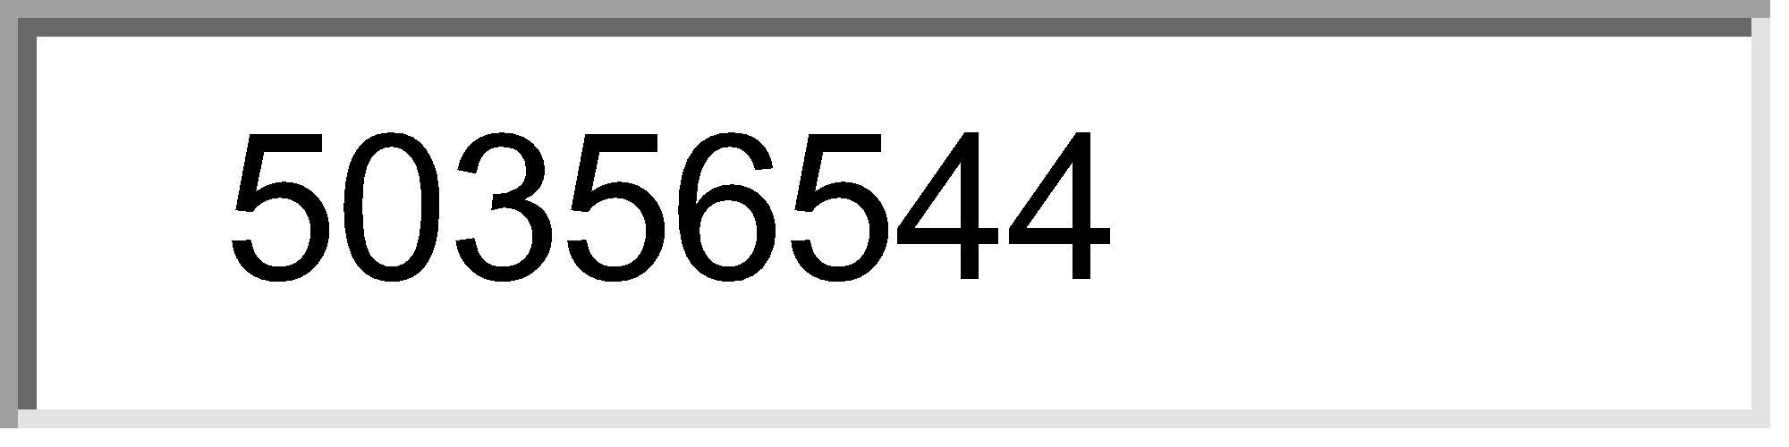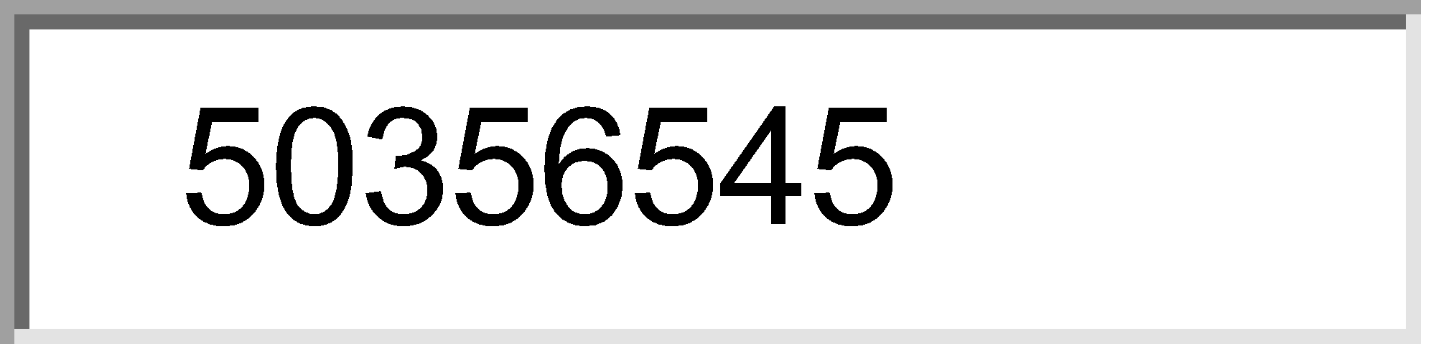

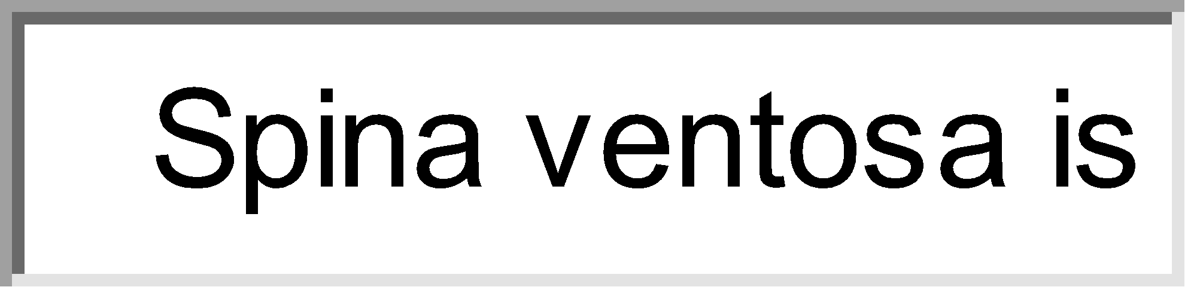

24) Spina ventosa is caused by :
One answer only. 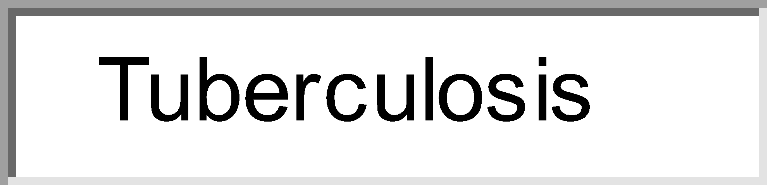
 Tuberculosis 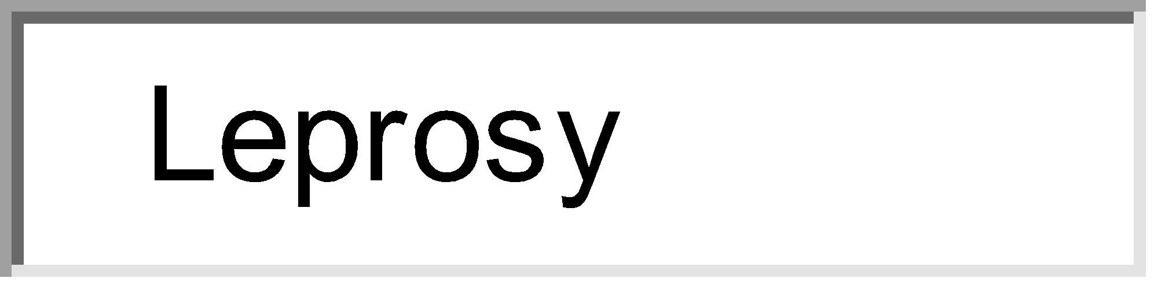
 Leprosy 
 Metastasis 
 Spine deformity

